Client Recruitment and Data Collection Protocol

Key
Green: Steps to complete
Blue: General Information
Red: Alerts
Orange: Steps

Identifying Potential Participants
- A link to the recruitment form is hosted on the learning management system (LMS) or the agency’s EHR database.
- A clinician or client clicks on the link to open the screener on REDCap.
- They the screener with recruitment information (name, contact , etc.).
- The form auto-generates a participant ID and includes client’s phone number and/or email address.
The client ID is a combination of the Site ID and their record ID.
- Site ID is the agency identifier:
  - P: Places for People
  - M: Mental Health Center of Greater Manchester
  - C: Community Partners
- ‘Record ID’ is the order of the screener when it was completed: 1 (first completed screener), 2 (second completed screener), 3...
So, the Client ID would be a combination of these two numbers (for e.g., M1, C2, P4, etc.)
- Set your email reminder (if this is your first time)
  - In the REDCap ‘Client Screener’ project, go to the ‘Alerts and Notifications’ page.
  - Click ‘Edit’ and add your email address as a recipient in Step 3.
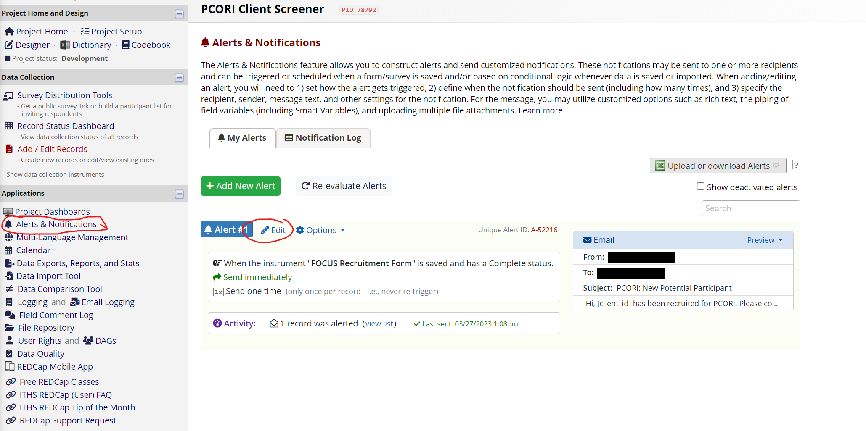
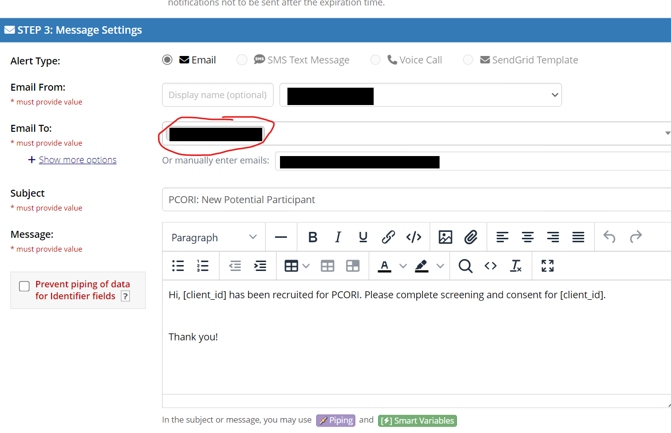
- You will now receive an email whenever a new form has been submitted. It will mention the client ID of the participant.
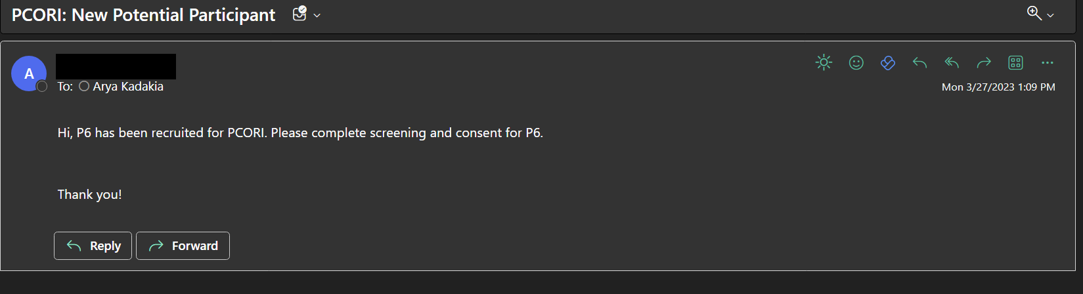
- When you get a new email alert, go back into the ‘Client Screener’ project and click on ‘Data Exports, Reports, and Stats’.
- Click on ‘View Report’ for the ‘Participant Status’ report. This is a report with specific information that will help with your consenting call.
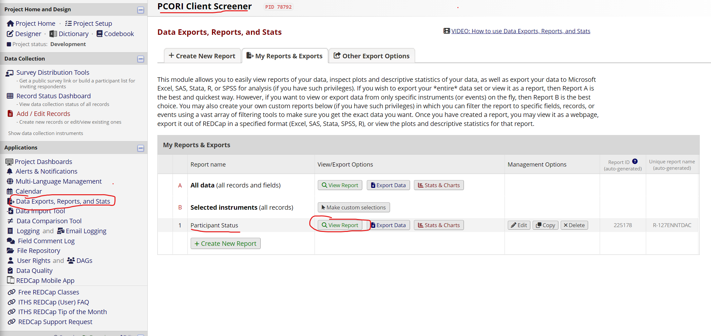
- Check the report to confirm whether the information for that particular client ID has been added. The report also includes the client’s name, phone number, clinician’s name, agency name, whether they want to participate in research, and outreach details.
- Identify a new participant by seeing that the ‘First text sent’ column is blank for that participant. This means that the participant has not been contacted yet.
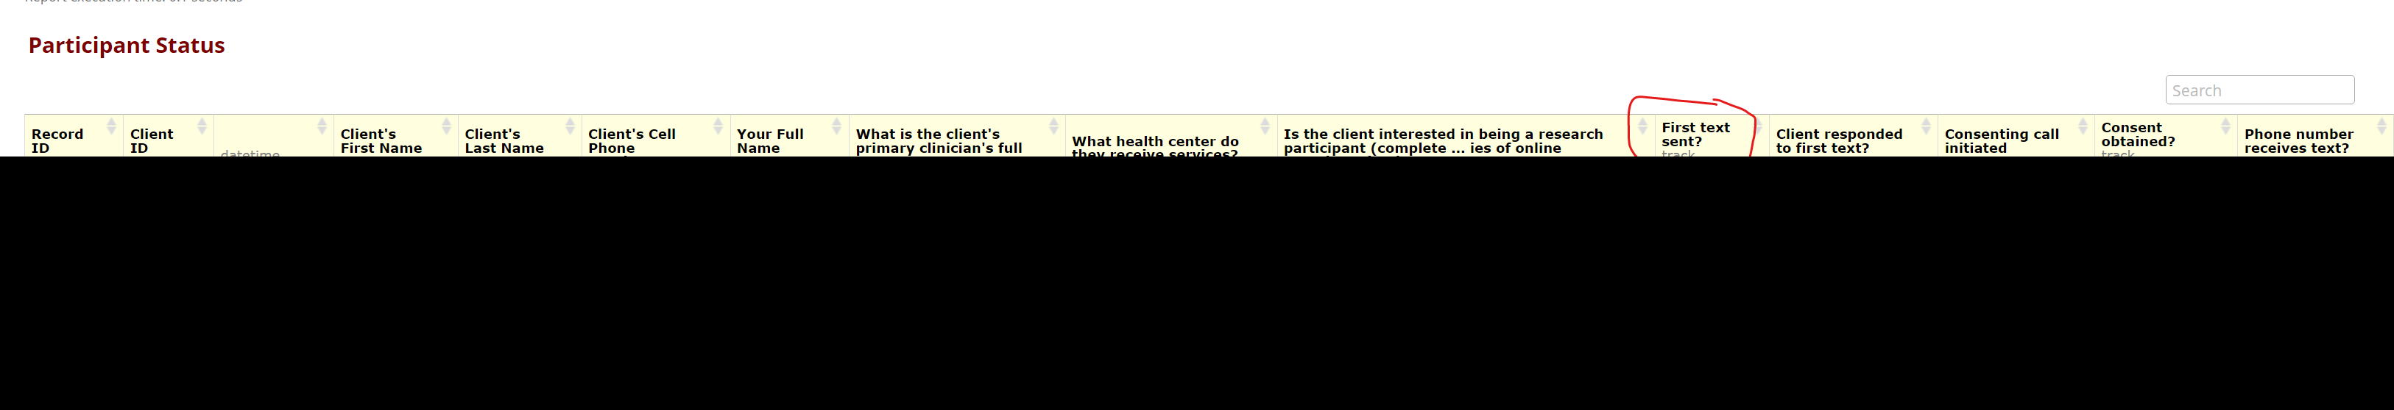
- Go to the next step, Participant Outreach: First Contact.

Participant Outreach: First Contact
- Once a client has been identified in the report, it’s time to contact them.
*Do not contact participants before 10AM*
* Before you send a text, double-check the phone number entered, along with the message to ensure things look correct. *
To protect privacy, please do not share any information about the study with the unknown person over text.
- Keep the Participant Status report open on your computer. Check the column that mentions whether the client is interested in being a research participant.
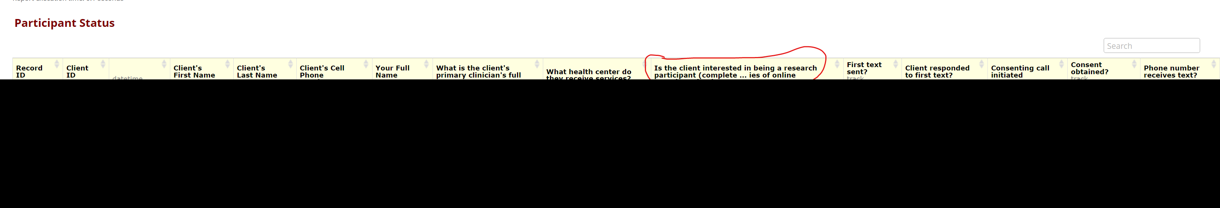
- If the participant IS interested in being a research participant, text them the following message from the STUDY PHONE:
“Hi, my name is Arya Kadakia from XXX. Is this [client name]?
(Yes) “Great! Your clinician at [health center] informed us that you were interested in participating in our study.
- (Yes) “Great! Do you have time now to chat over the phone about the study details and to determine your eligibility?”
  - (Yes) Perfect! Can I call this number? Proceed to Participant Outreach: Study Description (FOCUS + Study)
  - (No) That’s ok! Is there a better time to call back?
- (No) We appreciate your response. Can you let me know why you are not interested?
  - Even if you do not want to participate, you can still choose to use the FOCUS app. Do you have time now to chat over the phone about it?
    - (Yes) Perfect! Can I call this number? Proceed to Participant Outreach: Study Description (FOCUS only)
      - (No) That’s ok! Is there a better time to call back?
    - (No) That’s ok! Thank you for your time.

- At the same time as you text the client, on a new tab, open the ‘Record Status Dashboard’ in the ‘Client Screener’ REDCap.
- Click on the ‘Tracker Form’ for that participant’s record ID (can be found in the Participant Status report).
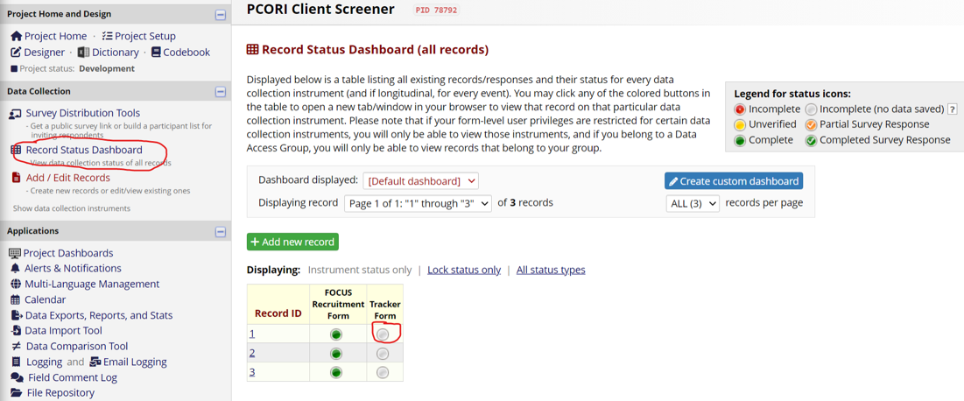
- When you open the form, it should look like this -
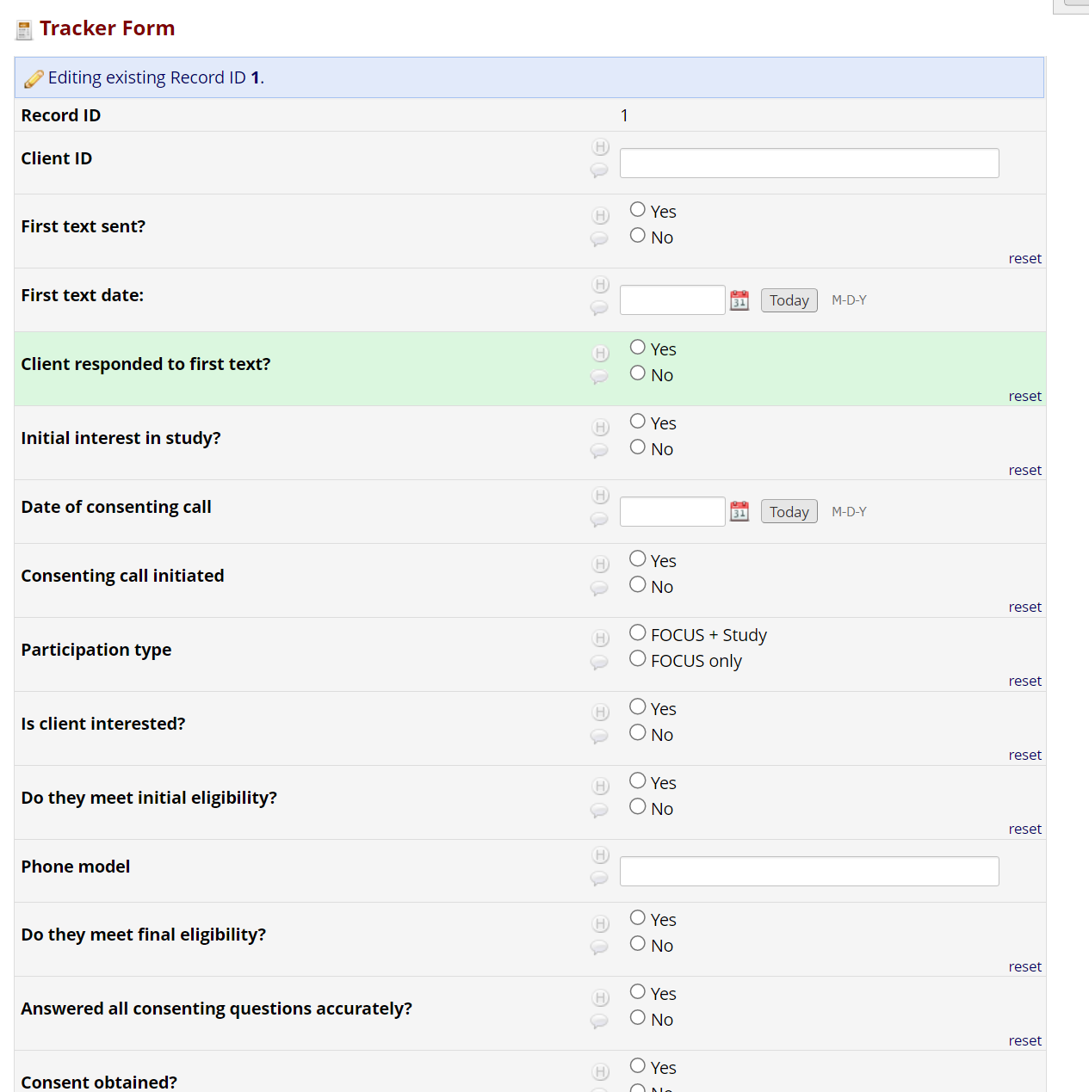
- Fill out the Client ID by copying from the Participant Status report, select ‘Yes’ to the ‘First text sent?’ question when you first reach out to the client and fill in the date that you did this in ‘First text date’.
- If you want to leave the form, leave it as ‘Incomplete’ and then click on ‘Save and Exit Form’. Do this every time you exit the form while it is incomplete!
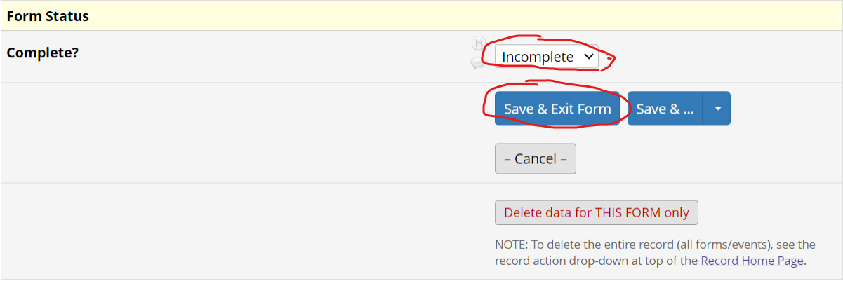
When you exit the page, the form will have a red circle like this -
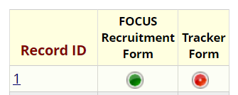
- Once the client responds, answer ‘Yes’ to the ‘Client responded to first text?’ question.
- Fill out the remaining boxes based on the client’s responses.
  - Initial interest in study – is the client interested in being a participant?
  - (Conditional) Reason for no interest – why the client is not interested
  - (Conditional) Still want to use FOCUS app – does the client still want the app?
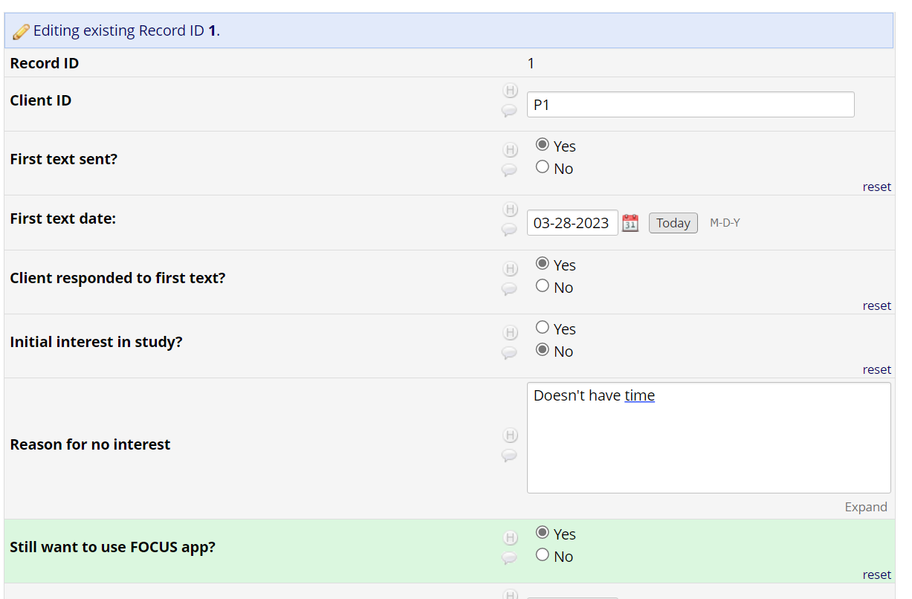
- Once you have a set a date and time for the consent and eligibility call, fill it out in the ‘Date and Time of consenting call’ question. If you do the call straight away, put in today’s date and time.
- Proceed to Participant Outreach: Study Description
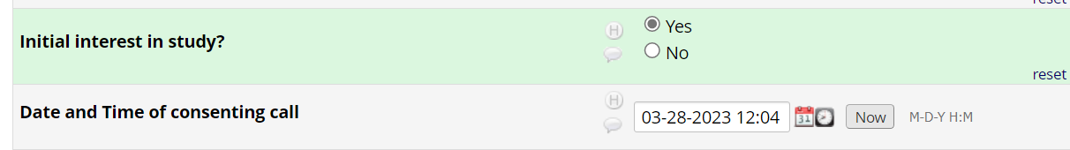

Outreach Schedule
- If the participant doesn’t respond to the first text in 1 day, do a follow-up call directly.
- Record in the tracker form if the follow-up call was made and the date that you did it.
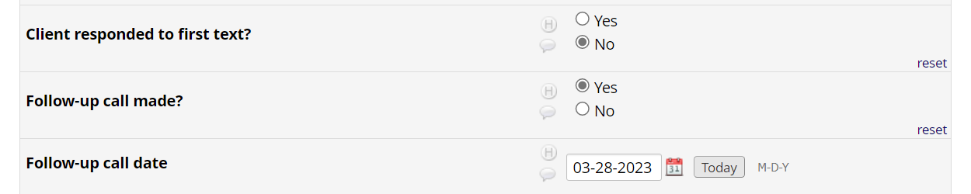
- If they pick up and you complete all steps in ‘Participant Outreach: First Contact’ over call, select ‘Yes’ to ‘Client responded to follow-up call?’ Complete the remaining fields in that step (up till ‘Date of consenting call’)
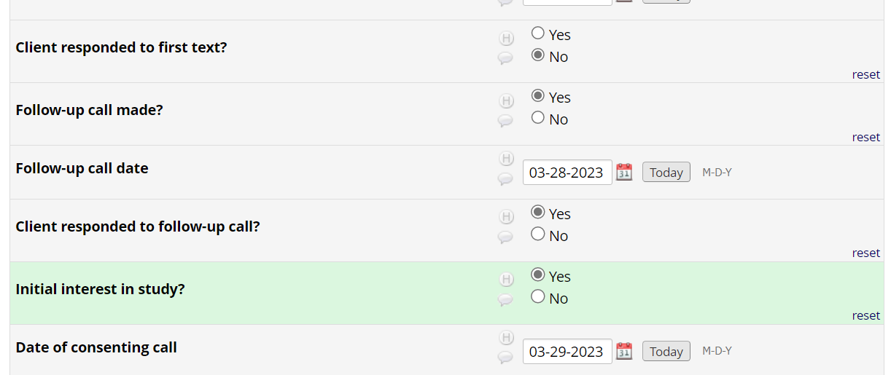
- If they do not pick up, text the following message:
Hi- just wondering if you have time over the next week to talk about the study. If you’re no longer interested, please send back “0” in a text. Thank you!”
- If there is no answer 1 day after the follow-up call, drop them from the reach out list. Put ‘yes’ in the ‘Client dropped’ field.
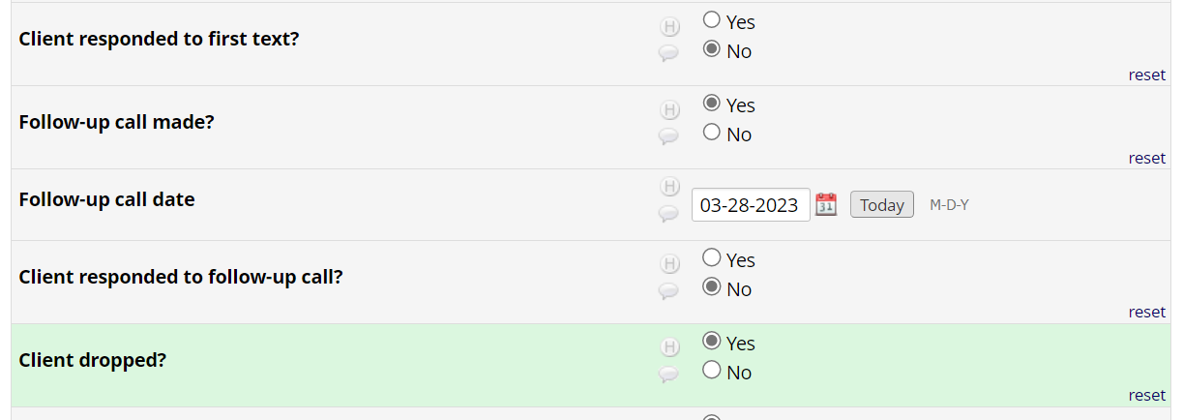
- If they don’t pick up but text and say that they are not interested, please send:
We appreciate the response. If you could let us know why that would be helpful. Please respond by sending the number for your reasoning. 1) too busy 2) no longer interested 3) technology concerns 4) other reason.
Thank you, we will no longer contact you.
- Put ‘yes’ in the ‘Client dropped’ field and record their response in the ‘Initial interest in study’ and ‘Reason for no interest’ fields.
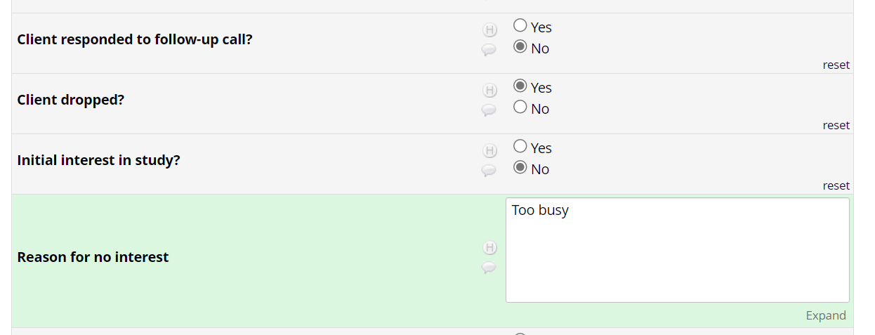

Participant Outreach: Study Description (FOCUS + Study)
- Call the client on the date and time specified in the Tracker form.
- Once you’ve initiated the call, put ‘Yes’ to ‘Consenting call initiated’ question.
- Specify that the client is interested in ‘FOCUS + Study’.
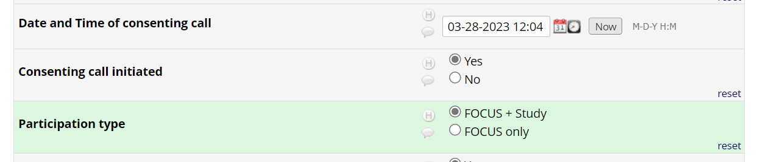
- Use this script with the client during the call:
“Thank you for your interest in the study! The purpose of the study is to test the roll out of smartphone intervention called FOCUS in mental health clinics around the country. This intervention includes two parts. 1) the FOCUS smartphone application which provides real-time / real-place illness symptom management skills. 2) Support from an mHealth Support Specialist, who will call you once a week throughout the 3-month intervention – each call lasting about 5-15 minutes. This person will be a member of your treatment team or clinic where you receive services. They’ll talk with you about your use of the smartphone application, recovery goals and FOCUS strategies.
If you are found eligible to participate in the study, the intervention will involve installing and using the FOCUS app on your smartphone. Over 3 months you will be asked to use the app, which delivers tips on how to manage various symptoms. A few questions will pop up on your phone three times a day asking you about how you are feeling, if you slept well, and other similar questions. Your responses in the application will be used by the mHealth Support Specialist to better understand how you are doing and will communicate this information to your treatment team.
The intervention will include using the app for 3 months and having 5 to 15-minute weekly calls with your mHealth Support Specialist. There will also be 2 research questionnaires that we will text to you to complete over your phone using a secure webpage. This will occur before you begin the study and then again after you finish and will include questions about symptoms, well-being, and how things went with the intervention. For these questionnaires, we ask that you have reliable data or WiFi in a quiet place for about an hour. You will receive a $XX visa card for each questionnaire you complete, which will be sent directly to your mailing address or could be picked up at your clinic.
Does this sound like something you would be interested in?”
If NO, “That’s ok! Do you mind letting me know why you don’t want to participate?” (record ‘no’ in ‘Is client interested’ and specify ‘Why is the client not interested’)
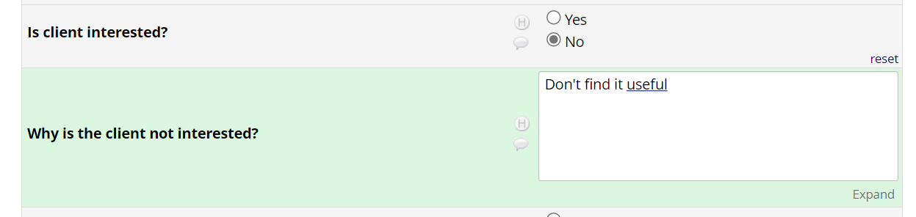
If YES, “Great! I have a few more questions to determine if you’re eligible” (record ‘yes’ in ‘Is client interested’ and move on to Participant Outreach: Eligibility)
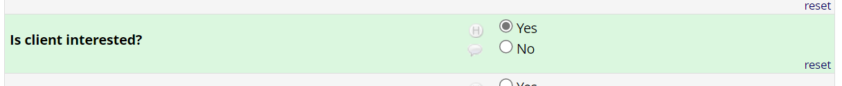
Participant Outreach: Study Description (FOCUS only)
- Call the client on the date and time specified in the Tracker form.
- Once you’ve initiated the call, put ‘Yes’ to ‘Consenting call initiated’ question.
- Specify that the client is interested in ‘FOCUS only’.
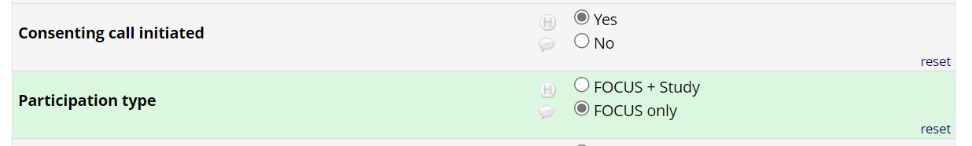
Hi, thank you for taking the time to talk to me about FOCUS today.
This intervention includes two parts. 1) the FOCUS smartphone application which provides real-time / real-place illness symptom management skills. 2) Support from an mHealth Support Specialist, who will call you once a week throughout the 3-month intervention – each call lasting about 5-15 minutes. This person will be a member of your treatment team or clinic where you receive services. They’ll talk with you about your use of the smartphone application, recovery goals and FOCUS strategies.
The intervention will involve installing and using the FOCUS app on your smartphone. Over 3 months you will be asked to use the app, which delivers tips on how to manage various symptoms. A few questions will pop up on your phone three times a day asking you about how you are feeling, if you slept well, and other similar questions. Your responses in the application will be used by the mHealth Support Specialist to better understand how you are doing and will communicate this information to your treatment team.
The intervention will include using the app for 3 months and having 5 to 15-minute weekly calls with your mHealth Support Specialist.
Does this sound like something you would be interested in?”
If NO, “That’s ok! Do you mind letting me know why you don’t want to use FOCUS?” (record ‘no’ in ‘Is client interested’ and specify ‘Why is the client not interested’)

If YES, “Great! I have a few more questions to determine if you’re eligible (record ‘yes’ in ‘Is client interested’ and move on to Participant Outreach: Eligibility)


Participant Outreach: Eligibility
- Ask the client the following questions to determine eligibility:
- “Are you over the age of 18?”
- “Do you own a smartphone? If so, what model?”
- “Can you speak English fluently?”
- “Are you receiving mental health services at [health center]
- Do you plan to continue services at this place for the next three months?”
Answering ‘no’ to any of these questions makes them ineligible to participate.
If they answer ‘no’ to any of these questions:
- Select ‘No’ to the questions that makes them ineligible and enter their phone model.
- ‘Do they meet initial eligibility’ shows 0.
- Tell the client that they are ineligible and end the call.
If yes to all, to all the questions above:
- Select ‘Yes’ to all the questions and put in their phone model.
- ‘Do they meet initial eligibility’ shows 1.

- Provide additional eligibility questions:
“Do you think you’ll have difficulty seeing or hearing the phone when you use it? Are you unable to read the screen and work the buttons on a touch screen phone?”
  - Assess how difficult- if they are unable to complete questionnaires or use FOCUS because of visual or physical impairment, they are not eligible.

“Do you have access to reliable Wi-Fi or data plan on your phone?”
  - IF NO, they are not eligible. (FOCUS requires very low data – day in day out over 3M= less than a gigabyte, Hard drive space requirements: 160mb)

“Do you share your phone with anyone else?” * nuanced question, worth discussing *
  - IF YES, they regularly do, they are not eligible.

- Select the corresponding responses in the tracker form
- You will see ‘1’ in ‘FOCUS Eligibility’ if they are eligible and ‘0’ if they are not eligible.
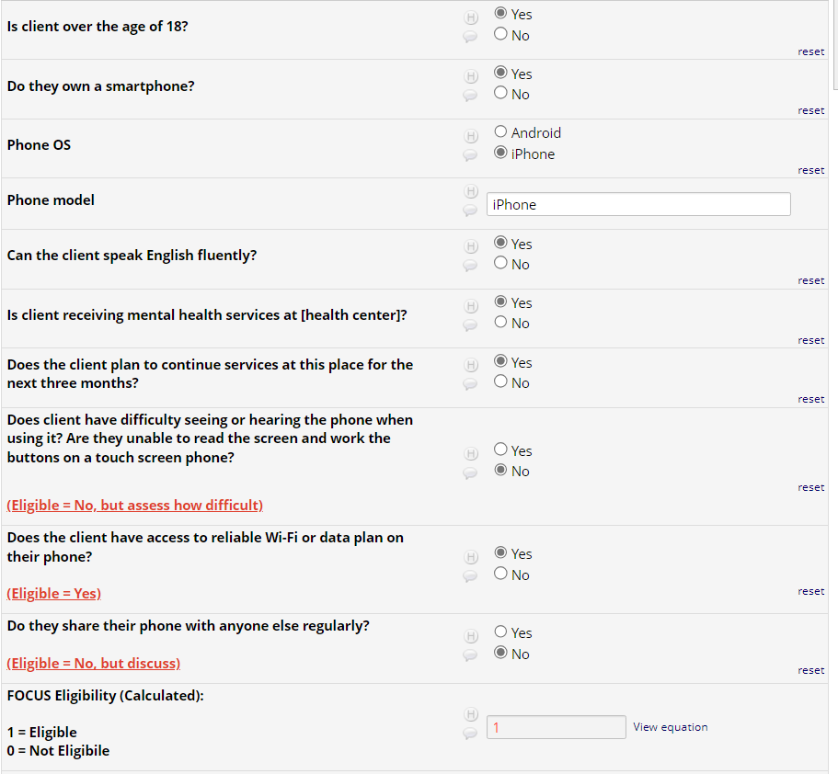
If eligible move to the next step depending on their participation type:
  - If FOCUS + STUDY, move on to Participant Outreach: Consenting
  - IF FOCUS ONLY, move on to Setting up FOCUS Accounts: Participants
If ineligible, tell the client they are ineligible and end the call.

- Additionally, ask them the following questions and input in the tracker accordingly. This does not determine eligibility; it is just for gathering data.
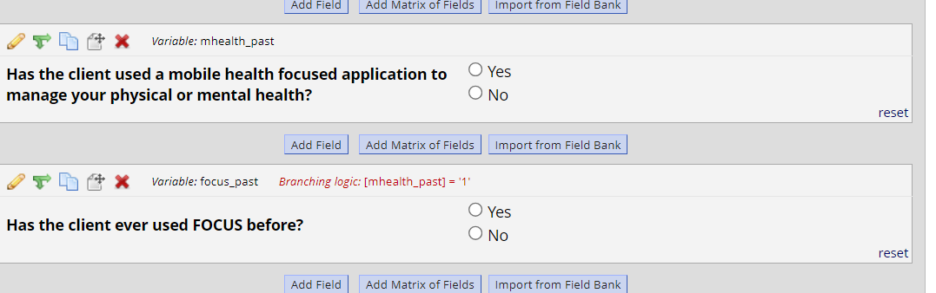

Participant Outreach: Consenting
- Continue with this script and enter responses in the Tracker form:
“Before we can officially enroll you in the study, I first need to ask you a few questions to make sure you understand key aspects of the study.
- “First, I hope I explained all of this well, can you summarize the study for me?”
Answer any questions or misunderstandings they may have. Repeat question if potential participant is unable to summarize the study. Note to interviewer: Make sure to ask how long the study is, what the study involves, and when/how they need to complete questionnaires.
- “The research questionnaire that will be texted to you 2x over the course of the study which includes questions about your health, mood and symptoms. Can you repeat the topics to me so that I can confirm you know what the questionnaires are about?”
- A. Lists all 3
- B. Lists any 2
- C. Lists only 1
- D. Incorrect answers
- E. Don’t Know
If the answer given is C, D, or E, repeat question 1. If the second answer given is C, D, or E, then end the screener. Do not sign consent. Otherwise, continue to question 3.
- “I want to remind you that your participation in this study is completely voluntary. You can decide whether to participate or not. You can also refuse to answer any questions during the questionnaires or stop at any time if the questions make you feel uncomfortable.
When I say completely voluntary, what does that mean to you?”
If respondent says “it is voluntary,” then probe for an explanation. An accurate answer is “it is my choice whether nor not to participate; I don’t have to do this (participate); I can do this (study) if I want, etc.

- “All of the information you provide through the FOCUS smartphone application will be kept confidential and be viewed by researchers and your clinical team ONLY. No one else will have access to the information you share with the FOCUS smartphone app.
When I say your data on the FOCUS smartphone app will be kept confidential, what does that mean to you?”
If respondent says “it is confidential,” then probe for an explanation. An accurate answer is “it will be secret; only authorized (some) people will see what I said; what I say will be (kept) private; it will be used for research,” etc.

- Have you ever participated in this study before? Participating includes downloading the app and completing some online questionnaires on your phone.

Incorrectly defines study/voluntary/confidential, do not obtain consent.
- In the tracker form, you will see ‘0’ in Study Eligibility\
- Tell the client they are ineligible for the study but can still use FOCUS app. Answer yes to “Still want to use FOCUS?”
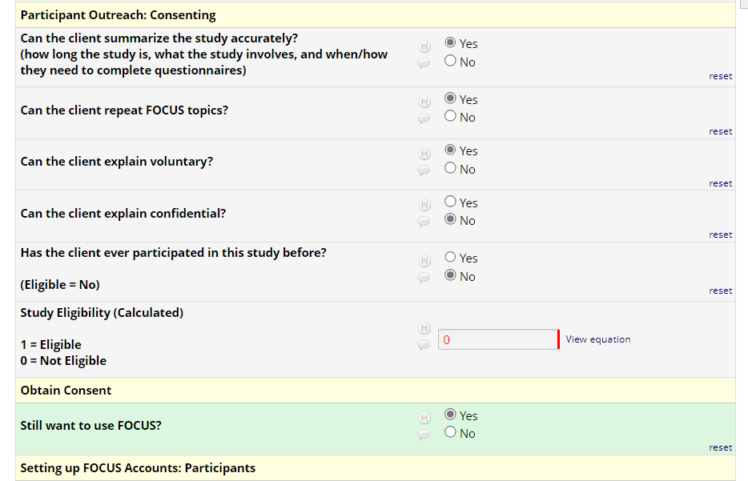
- Move to Setting up FOCUS Accounts: Participants

correctly defines study/topics/voluntary/confidential/no prior participation:
- In the tracker form, you will see ‘1’ in Study Eligibility
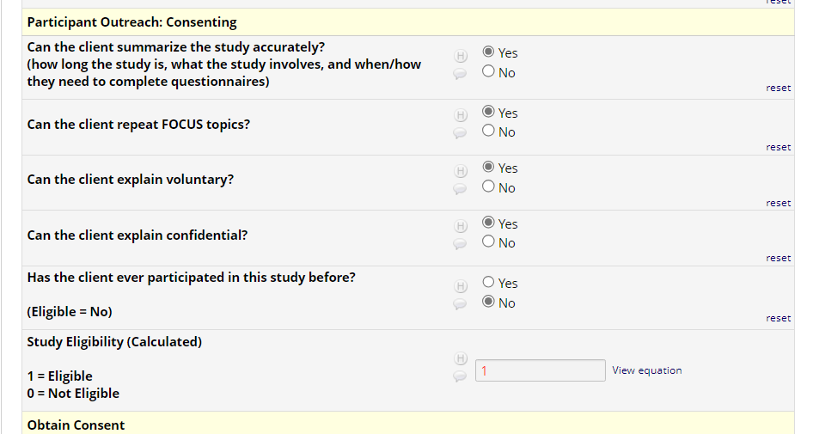
- Continue with the script:
Great! I’d like to also note the differences between the information you send through the FOCUS smartphone app verses your responses to the questionnaires that we will text to you.
As part of the study, you will be asked to install the FOCUS smartphone app on your phone. What you share in the FOCUS smartphone application will be shared with your clinical team.
This is different than the questionnaires I will text to you- which your responses to those questions will ONLY be with the research team. In fact, after we are done with the call, I will send you one to complete!
As I’m sure you’ll remember, you will be asked to answer 2 batches of questionnaires throughout the study- once when you begin- I’ll send this to you after our call if you choose to become a participant. Another will be sent when you finish the intervention. For each assessment you complete you’ll be sent a $XX gift card. Once again- your responses to the texted questionnaires will NOT be shared with your clinical team and will stay with the research team.
- Move on to Obtain Consent.

Obtain Consent
- Once a potential participant correctly responds to the consenting questions, then ask them for verbal consent:
“Great! It sounds like you understand what the study is about. I am going to now ask you to sign our consent form over the phone.
IF they refuse:
- Use this script:
“Ok, that’s not a problem. For our research records, can you please let me know why you’re not interested?” Make sure to record their answer. If they say they’re not interested, probe further to obtain a reason why they’re not interested.
- Put ‘No’ in the ‘Consent obtained?’ question and record the reason ‘why the client does not want to participate’.
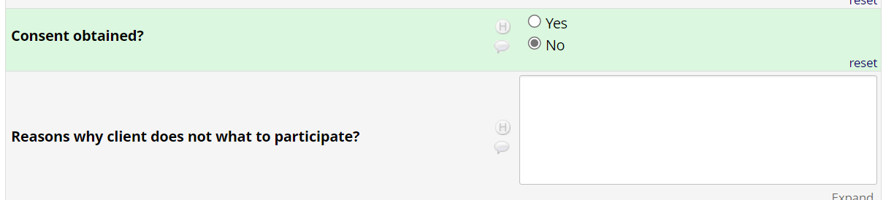
IF they sign:
- Put ‘Yes’ in the ‘Consent obtained?’ question.
- Describe the questionnaire and how they will receive the link.
“In the next day or so, I’ll send you a link to the online questionnaire in a text from +1 (XXX) XXX-XXXX. Can I confirm that this phone number receives text messages?
IF YES:
- Put ‘Yes’ in the ‘Phone number receives text?’ question.
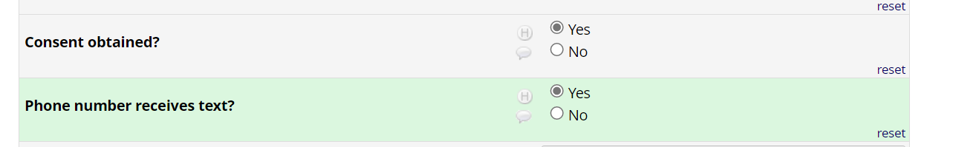
IF NO:
- Asks them: “Do you have an email address that you would like to use instead to receive the links to the surveys?”
- Put ‘No’ in the ‘Phone number receives text?’ question and record their email in the ‘Email alternative’ box.
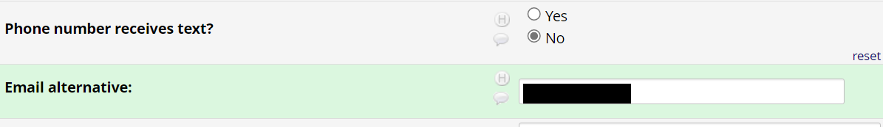
- Continue with this script:
It’s important that when you are ready to take the questionnaire to be in a quiet place with no distractions, such as roommates or children. It is also important that you have a strong cell connection with your data plan or WiFi. The link to the questionnaire will open in a webpage and will ask you questions that will require pressing buttons on your phone. You won’t be able to go back so please make sure to think about your answers before hitting the next arrow button.
Once again, there will be 2 things you’ll need for the questionnaire:
- Good data connection
- Quiet place with NO distractions for 30minutes – an hour
Do you know of a time in the next few days you can sit down and go throughout the questionnaire?”
“If we see you haven’t started it in a few days, we will reach out to help.”
- Ask them for their preference on where to deliver the gift cards.
Lastly, we need to know where to send your gift card. Do you prefer it sent to your health center or to your home address?
- Agency: Select ‘Agency’ in the ‘Gift card location preference’ question and choose which agency.
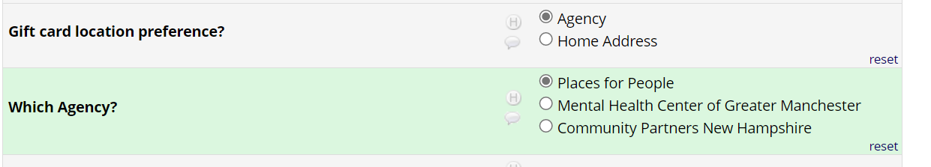
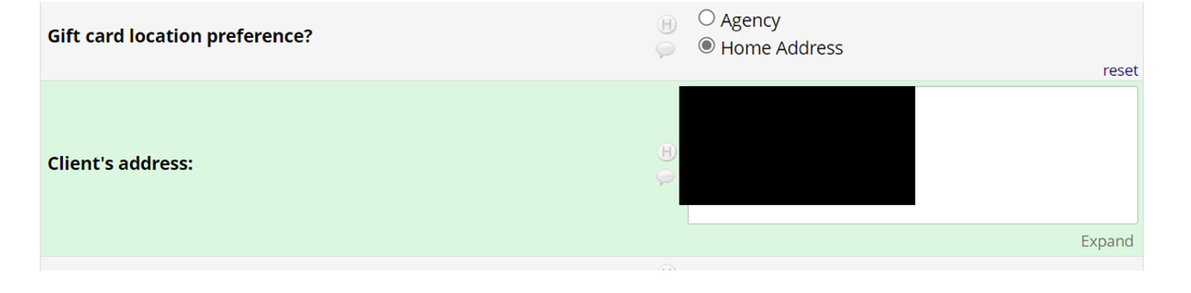
- Home Address: Select 'Home Address’ in the ‘Gift card location preference’ question. Ask them for their home address and fill it out in the following box.

Make sure to inform them of their mHealth Support specialist and that FOCUS is NOT publicly available and to wait for the mHealth installation call.
After consenting and ensuring they will be able to complete the questionnaire let the participant know that they can request help anytime they need it.
- After getting off the phone with the participant, click ‘Save & Exit Form’ while incomplete.

- Now go to the RedCap: Client Baseline step.

REDCap: Client Baseline
- On one tab, open the ‘Participant Status’ report in the Client Screener REDCap. Keep the tracker form open on the other tab.

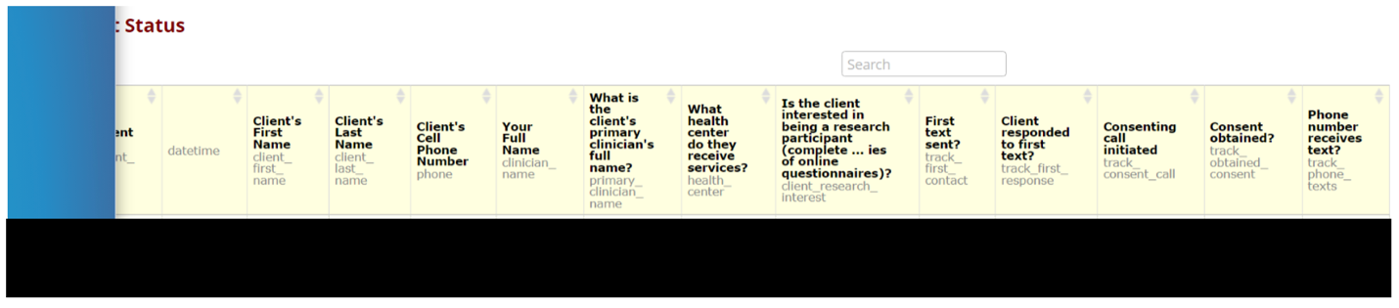
- Confirm if consent has been obtained and if that participant’s phone number receives text (last two columns).

- On a separate tab, go to the ‘Client Assessments’ REDCap project.
- Go to the ‘Survey Distribution Tools’ page on the left and click on ‘Participant List’.
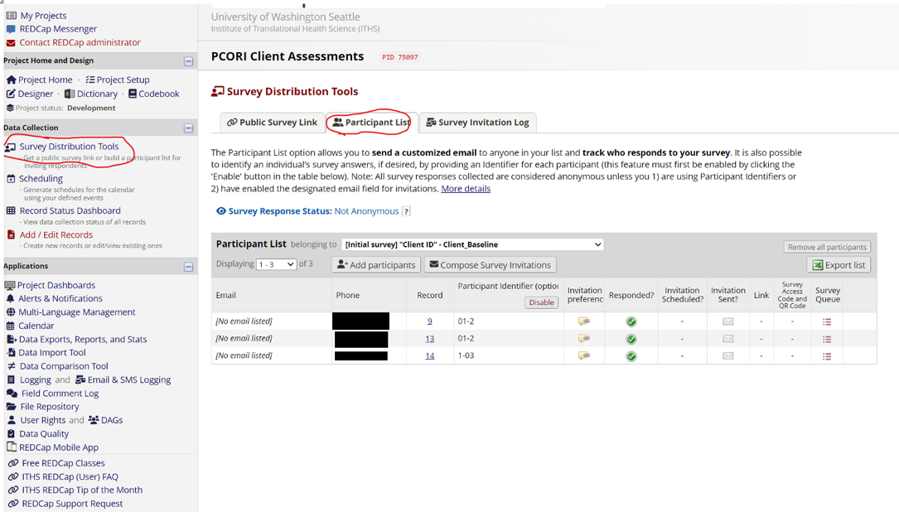
- Make sure the list belongs to ‘Client ID Baseline’ by clicking on the drop-down list at the top of the table.
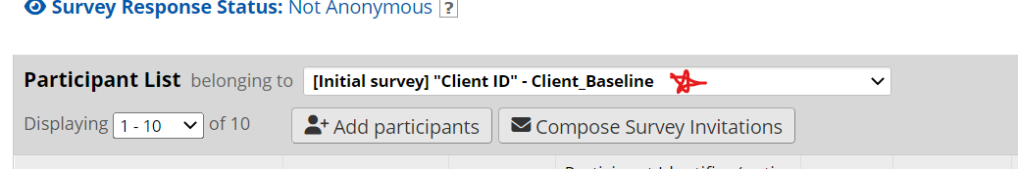
- Click on ‘Add participants’.
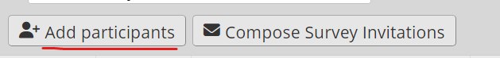
- Here you will input the phone number and ID taken from the Participant Status report (e.g., 6036678590, P3). This should automatically populate the ‘Phone’ and ‘Participant identifier’ columns.
NOTE: These screenshots show client ID’s as 2-03, 1-03, etc. HOWEVER, you will be using the IDs from the screener (M1, C2, P3, etc.)
IF THE CLIENT ID IS INACCURATELY DONE THIS HAS HUGE IMPLICATIONS FOR THE PROJECT.
PLEASE TAKE YOUR TIME WITH THIS- it’s OK to take more time and not rush! This is more important than ‘productivity’
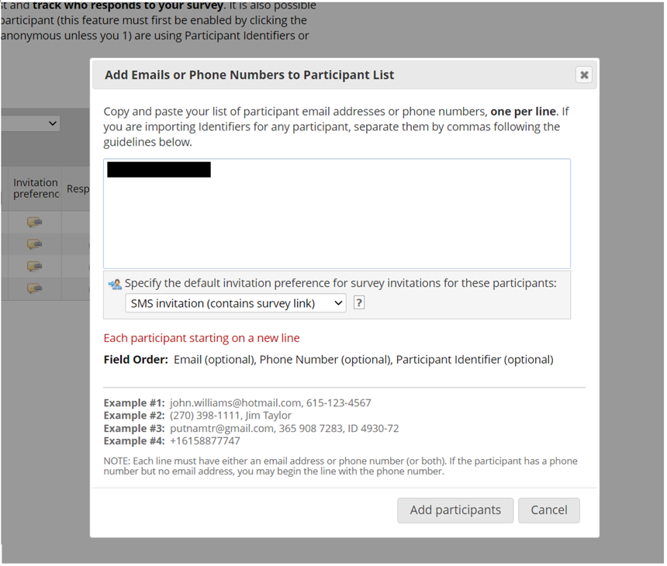
- Open the URL link next to the corresponding participant on a new tab.
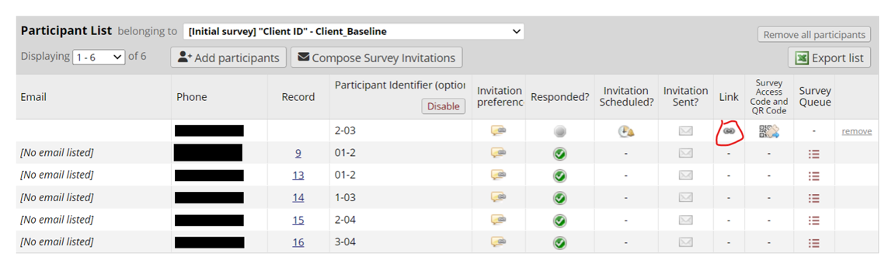
- Fill out the ‘Client ID’ form with the same ID from the tracker form and then press submit.
Make sure ‘Error, IDs do not match’ disappears before pressing submit. Make sure the IDs are correct before pressing submit. This has SERIOUS IMPLICATIONS if this ID is mis-entered. Please be careful!
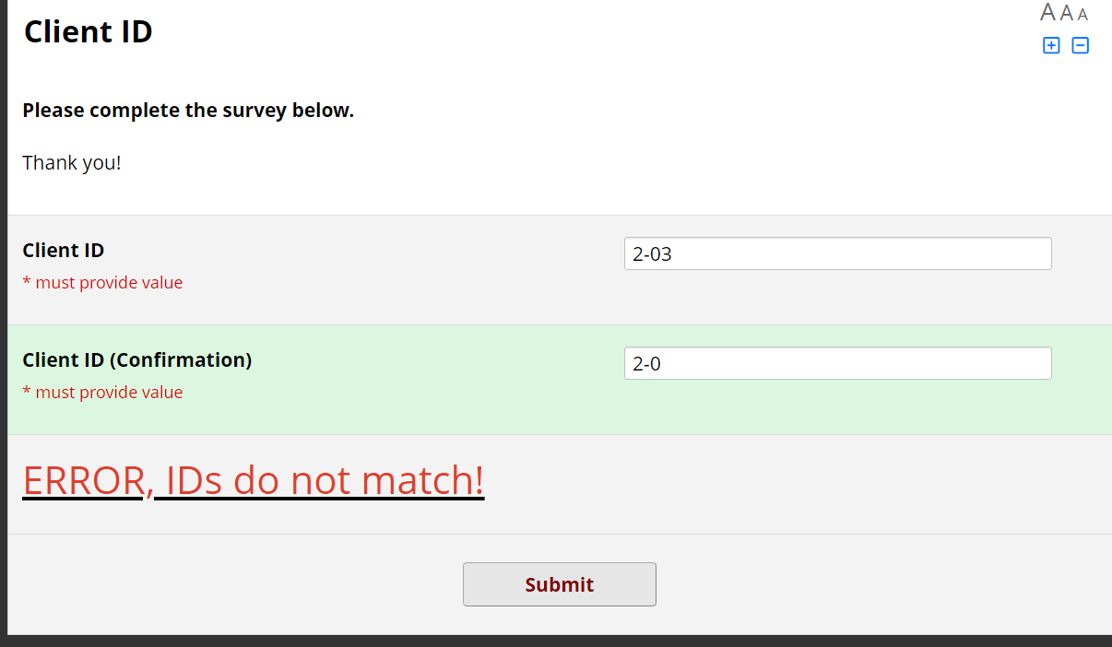
- Submit the form. Go back to the “Participant List” and refresh the page. There will no longer be a URL link to click on. The ‘Participant List’ should now look like this:
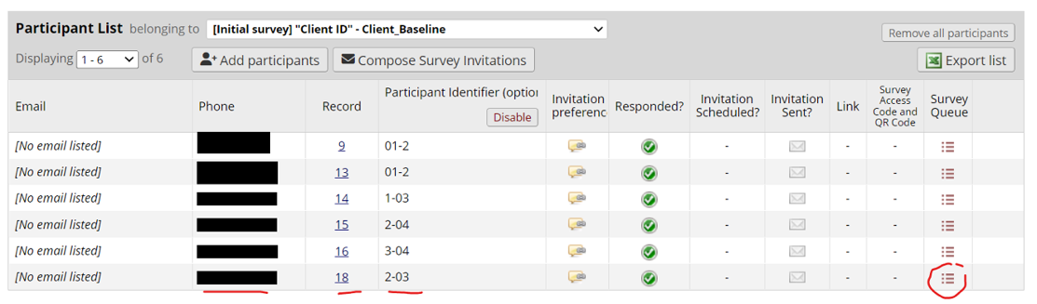
- Next, while still on the Participant List in ‘Survey Distribution Tools’, click on the drop-down list at the top of the table and select Demographics - Client Baseline’.
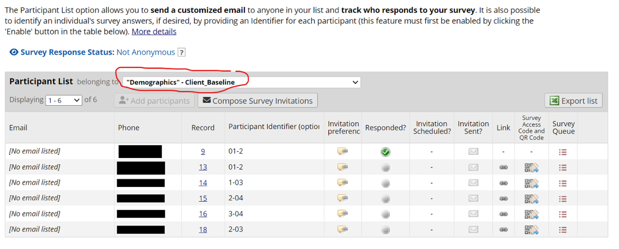
- Click on ‘Compose Survey Invitation’.
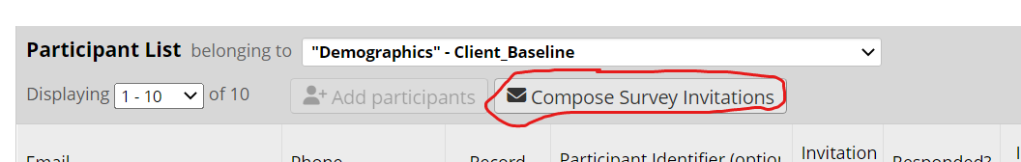
- On the right you will see a list of the phone numbers. Select the phone number(s) in the Participant List on the right by checking the box next to it (only the new numbers should show up provided that you’ve already sent out the invitations to the previous ones).
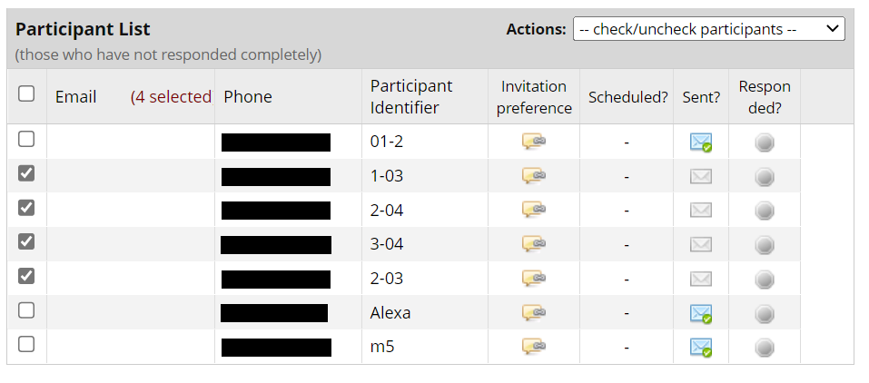
- Choose SMS invitation as the Invitation type.
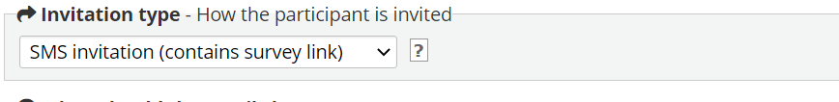
- Ensure that the messages are being sent ‘Immediately’
- Enable reminders to be sent every 2 days (recurring up to 2 times). This only reminds participants who have not completed the Demographics survey. It DOES NOT remind participants if they have stopped on any of the other surveys.
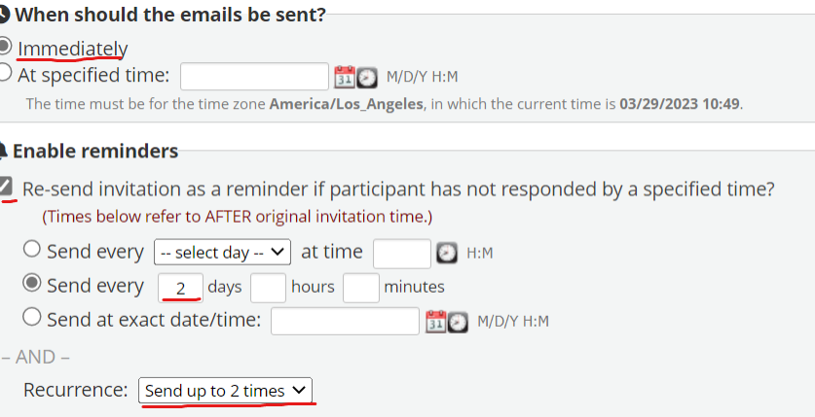
- Use the following message in the body of the message -
Hi there! Congratulations on being a participant in our study. Below is a link to the questionnaire.
Please make sure to have a good Wi-Fi or data connection and be in a quiet place without distractions. The questionnaire should take between 30-60 minutes.
If you have questions, you can text us back on XXX-XXX-XXXX.
Thank you!
[survey-url]
- Here’s what the page should look like at the end. For future messages, you can select a previously sent message from the dropdown menu at the bottom of box.
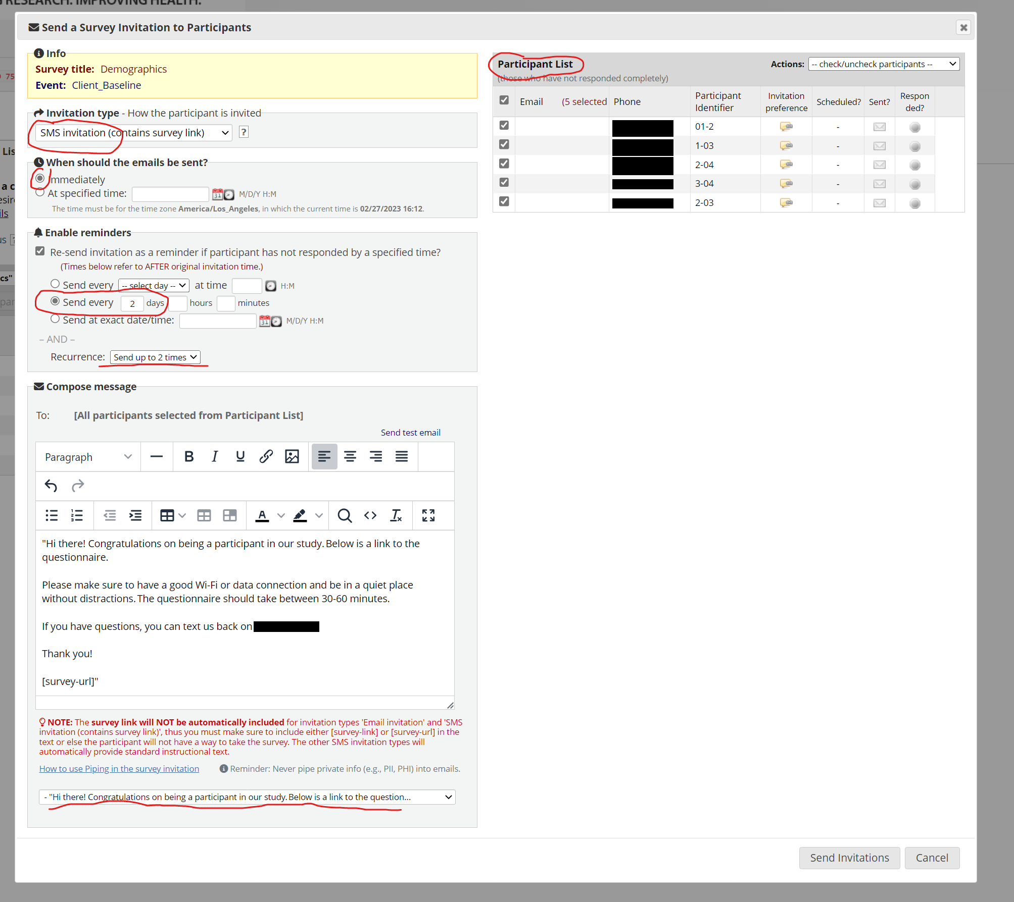
- Inform the participants from STUDY PHONE that they should receive a link to the surveys.
IF they do not receive the Twilio text message, send them the URL to the demographics survey through the STUDY PHONE.
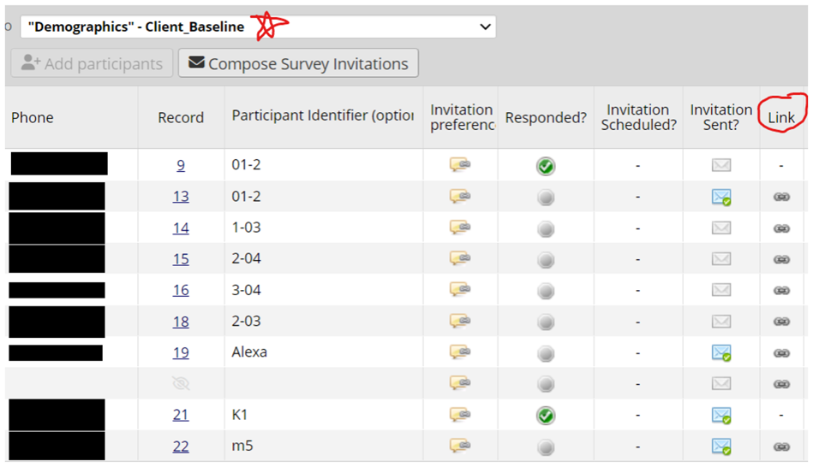
- Once the participant has completed baseline assessments, you will receive an email with that participant's Client ID and Record ID.
- Click on Record Status Dashboard.
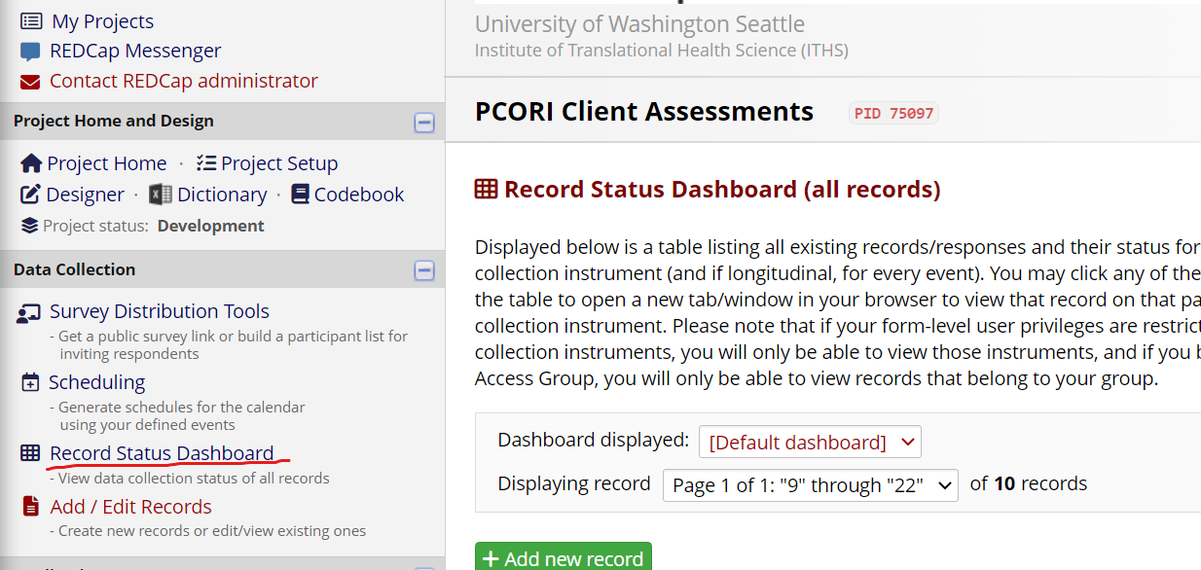
- Confirm that the participant (based on the Record ID) has completed all surveys (green circle with tick mark).
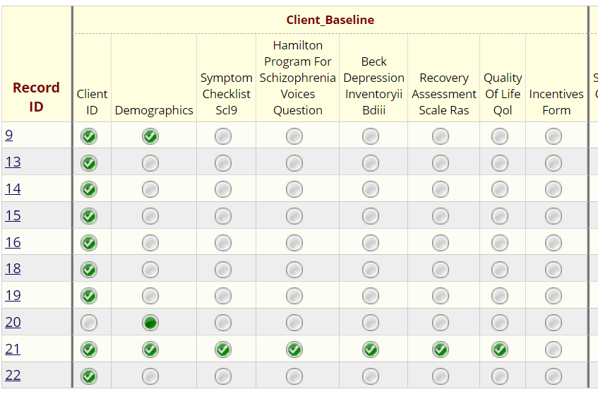
- If you notice that a participant has not completed all assessments, send them a reminder text using the STUDY PHONE. You can find the phone number linked to a particular Record ID in the Participant List.
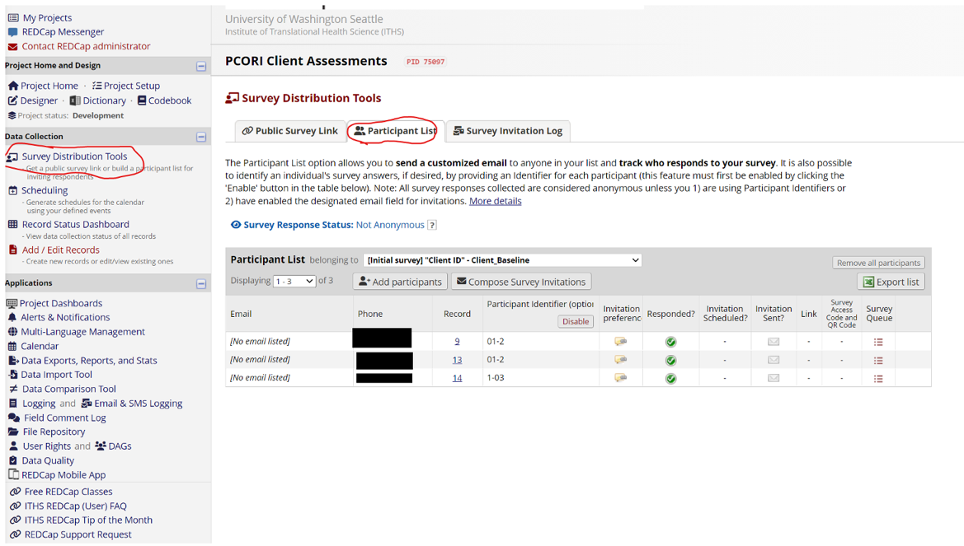
- Click on the circle for the Incentives Form in the Record Status Dashboard.
- Do this at the end of EVERY WEEK to see if any client have incomplete surveys.
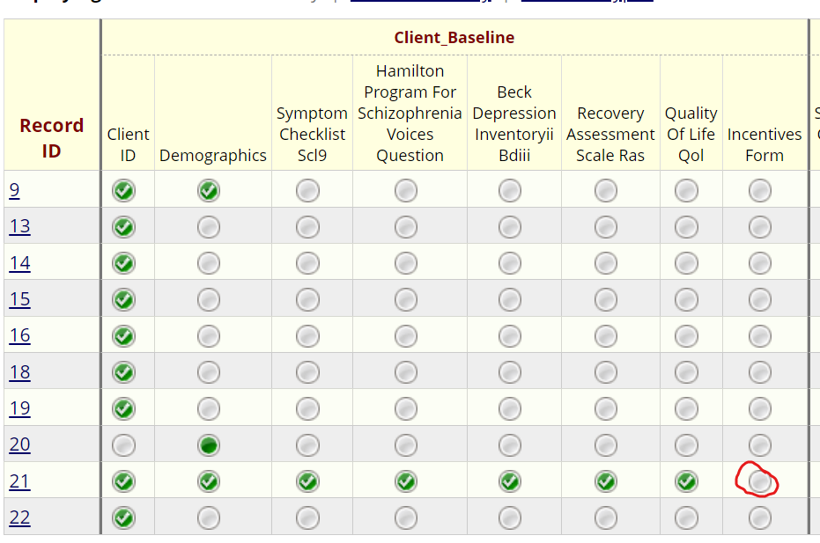
- Click ‘Yes’ for ‘Completed all surveys?’
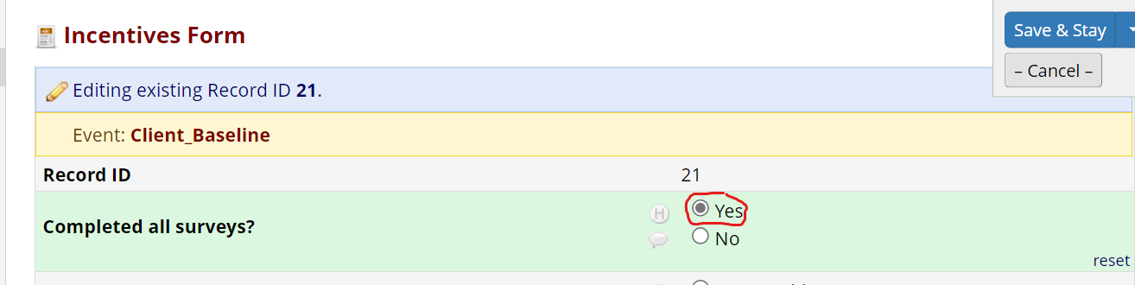
- Leave as Incomplete and press Save & Exit Form.
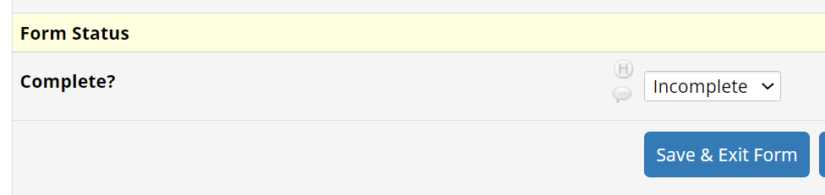
- Now you can move on to the Setting up FOCUS Accounts: Participants step.

Setting up FOCUS Accounts: Participants
- To set up a FOCUS user access visit: https://app.focusdash.org/
- Using your username and password of an admin user, log into the FOCUS dashboard.
Username: XYZ
Password: ABC
- Once logged in, select ‘Participants.’
FOCUS User IDs combine the SITE (clinic) with the Record ID from the screener. This is the same format / ID as was entered in the participant list and survey link (M1, P2, C3, etc.)
Password: Develop a password that will be easy to share over the phone. A simple set of 4 numbers should work, then enter it twice (i.e. 16701670 – just try to avoid 1234, or 5555, or 0000 / 1111. etc).
- Once the Participant ID and password are entered into the dashboard, select the participating site and clinicians who will be granted access to that users data in the dashboard:
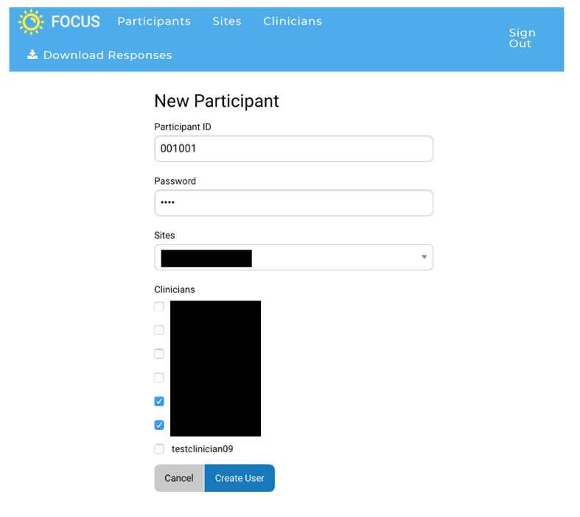
- Open Client Screener on a new tab.
- Go to Data Exports, Reports, and Stats and click on 'View Report’ next to Participant Status Report.

- Check the participant’s Record ID.
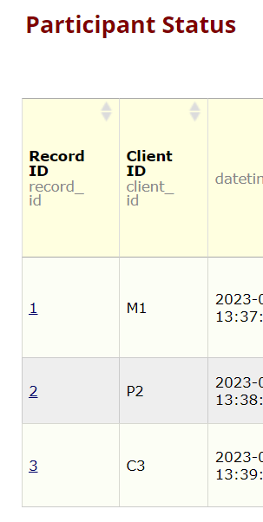
- On a different tab, go to the Record Status Dashboard page on the left and then click on the tracker form for that particular Record ID.
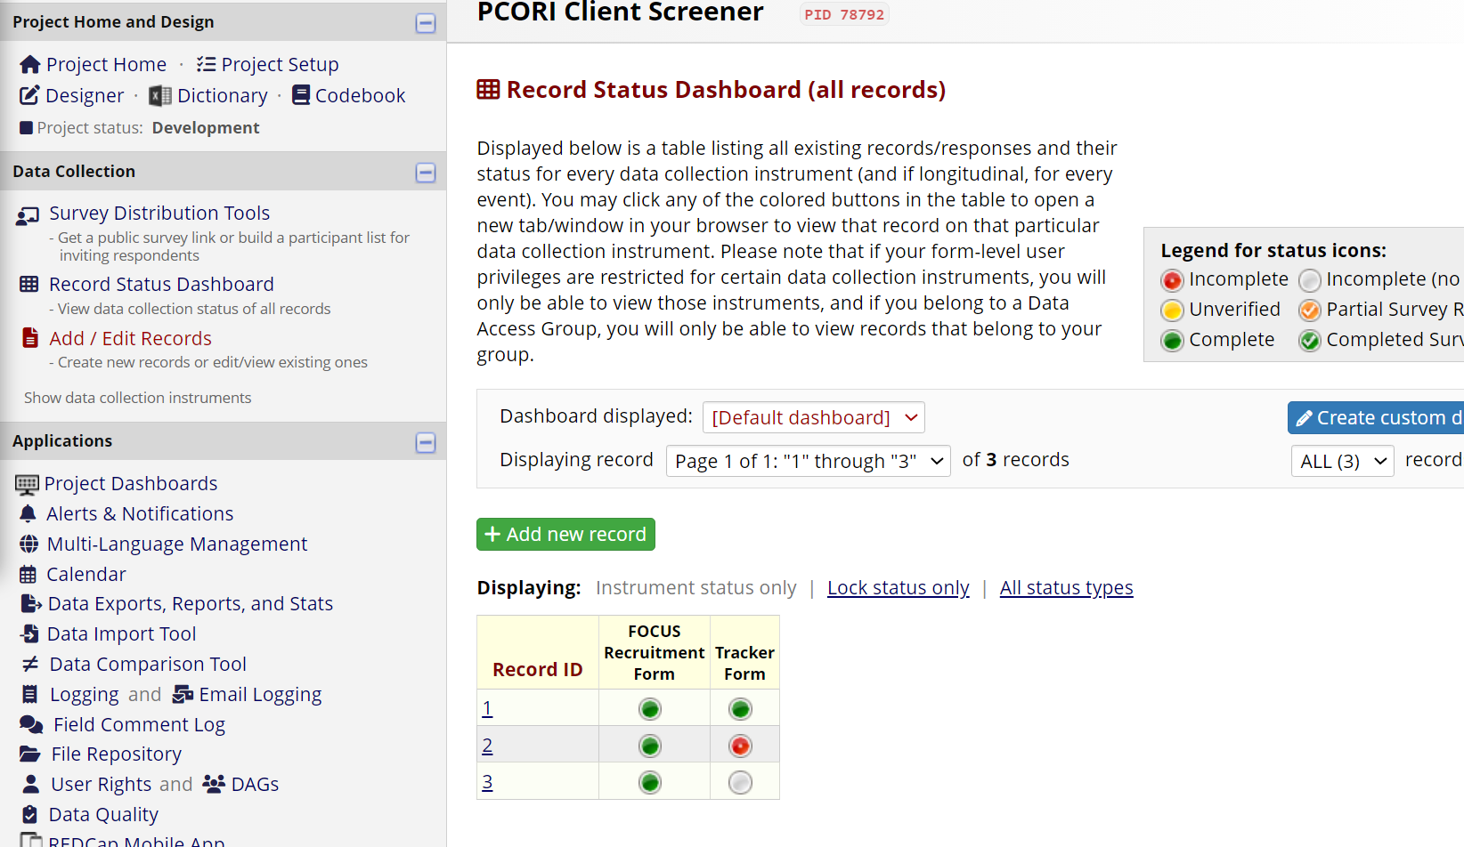
- Write down the FOCUS ID and password. Save and exit the form.
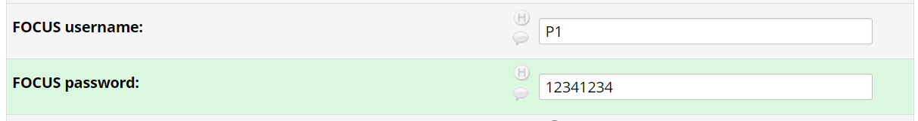
This will be communicated to mHealth Support Specialists and may be needed to log in folks if they switch phones or re-installed the app.
- Move on to next step, ‘Participant Incentive’

Participant Incentive
- In the Client Screener REDCap, go to Data Exports, Reports, and Stats. Click on ‘View Report’ for the third report, ‘Incentive Preferences’.
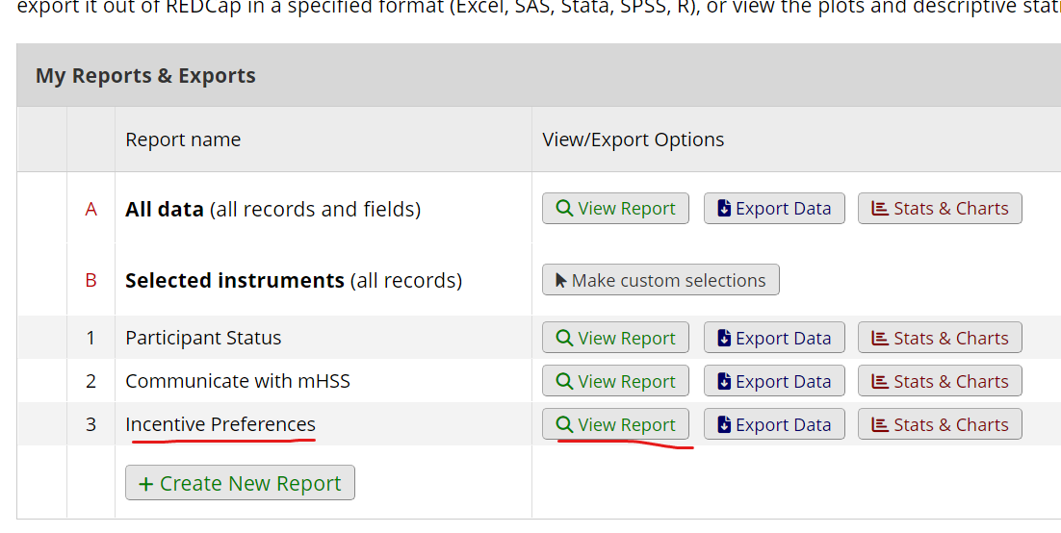
- Identify the incentive preferences for that particular client ID.
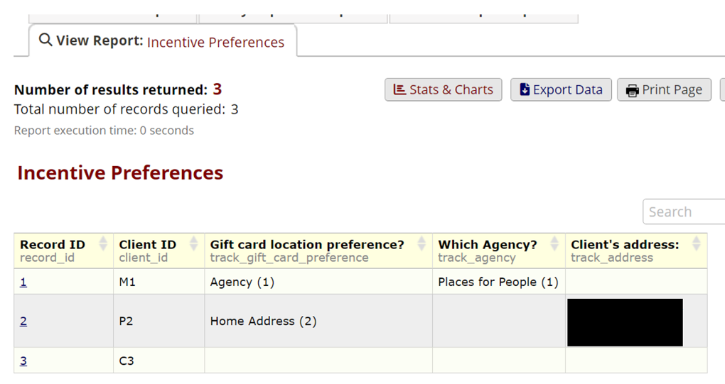
- On a new tab, go to the Client Assessment’s project and click on ‘Data Exports, Reports, and Stats’ on the left.
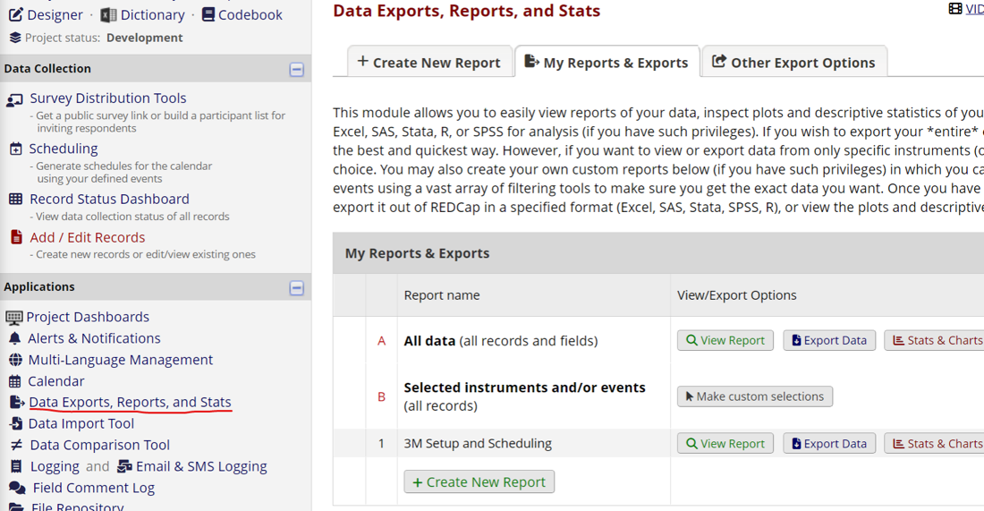
- Select ‘View Report’ for 3M Setup and Scheduling’.
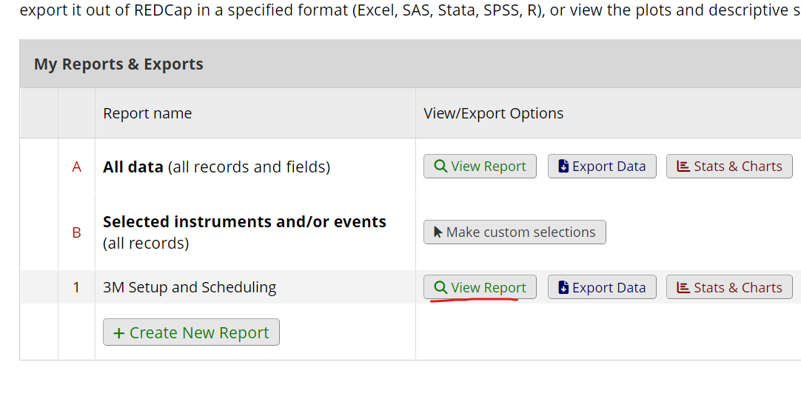
- Click on the Record ID of the Client ID that you are working on. Make sure it says ‘Yes’ to ‘Completed all surveys’.
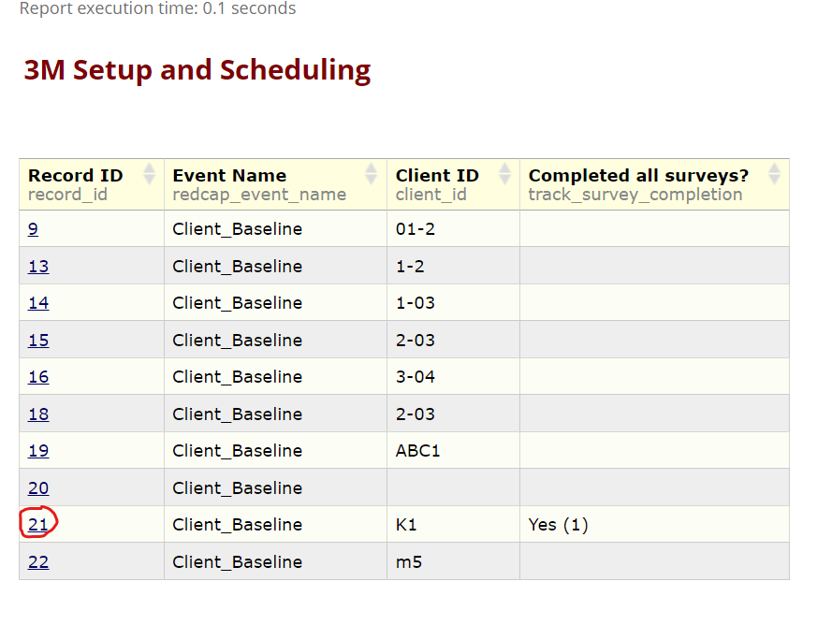
- This will open the record home page for that particular record. Click on the Incentives Form for that record.
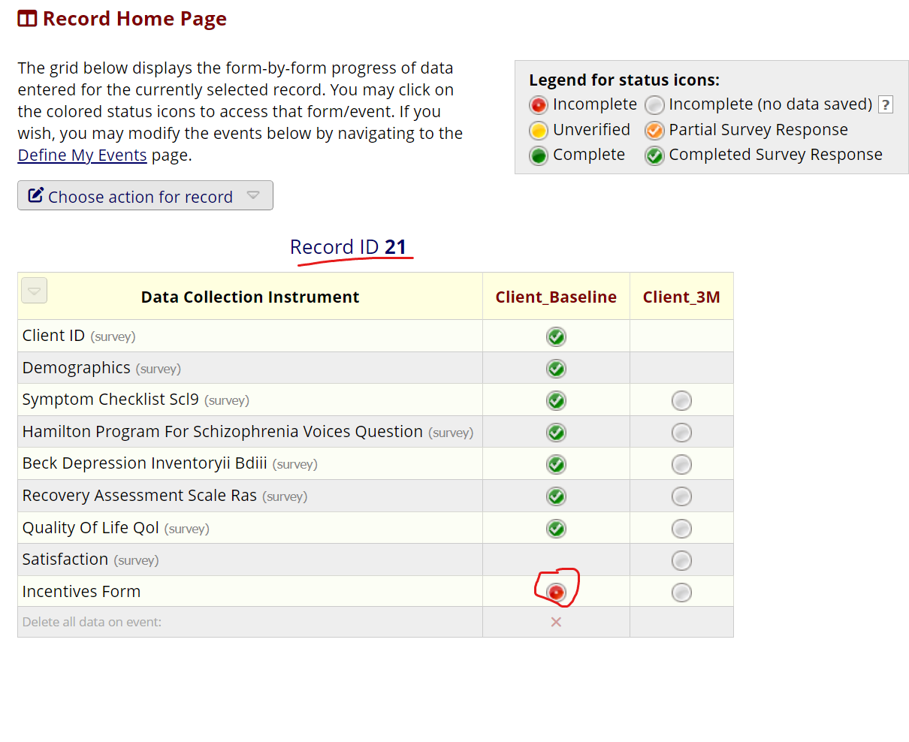
- Enter their preference for where they want the gift card to be sent in ‘Location for gift card’ using the information.

Pick up at agency:
- Reach out to the mHSS to notify them that the participant will head down to pick up their incentive and you will be mailing one to them to hand out.
- Inform the participants the incentive will be ready for them to pick up at the end of the following week.
Directly mailed:
- Using the mailing address provided during screening, mail out an incentive from the supply.

- Once you have mailed the gift card, select ‘Yes’ to ‘Gift card sent?’ in the Incentives Form.
- Go to next step, ‘Outreach to mHSS about new participant’.

Processing Incentive
This step is only needed for purchasing new gift cards. Skip this step if you have already purchased them.
- Go to http://www.prepaid-usa.com.
- Select PrePaid-USA Visa Incentive Card on the top menu.
- Navigate to the Quick Quote Section.
- Fill out the name and other basic info.
- Fill in desired amount (10 per site to begin with @ 40 dollars each and some for us to send by mail).
- May have to do separate quotes for each site address you are shipping to
- Wait for email with quote.
- Follow instructions in email to purchase the cards with the PCard.
- Address them to the Clinics they need to go to.

Outreach to mHSS about new participant
- Once the participant has completed the baseline questionnaires and has been sent their incentive, go to the Client Screener REDCap.
- Click on Data Exports, Reports, and Stats and click on ‘View Report’ for the ‘Communicate with mHSS’ report.
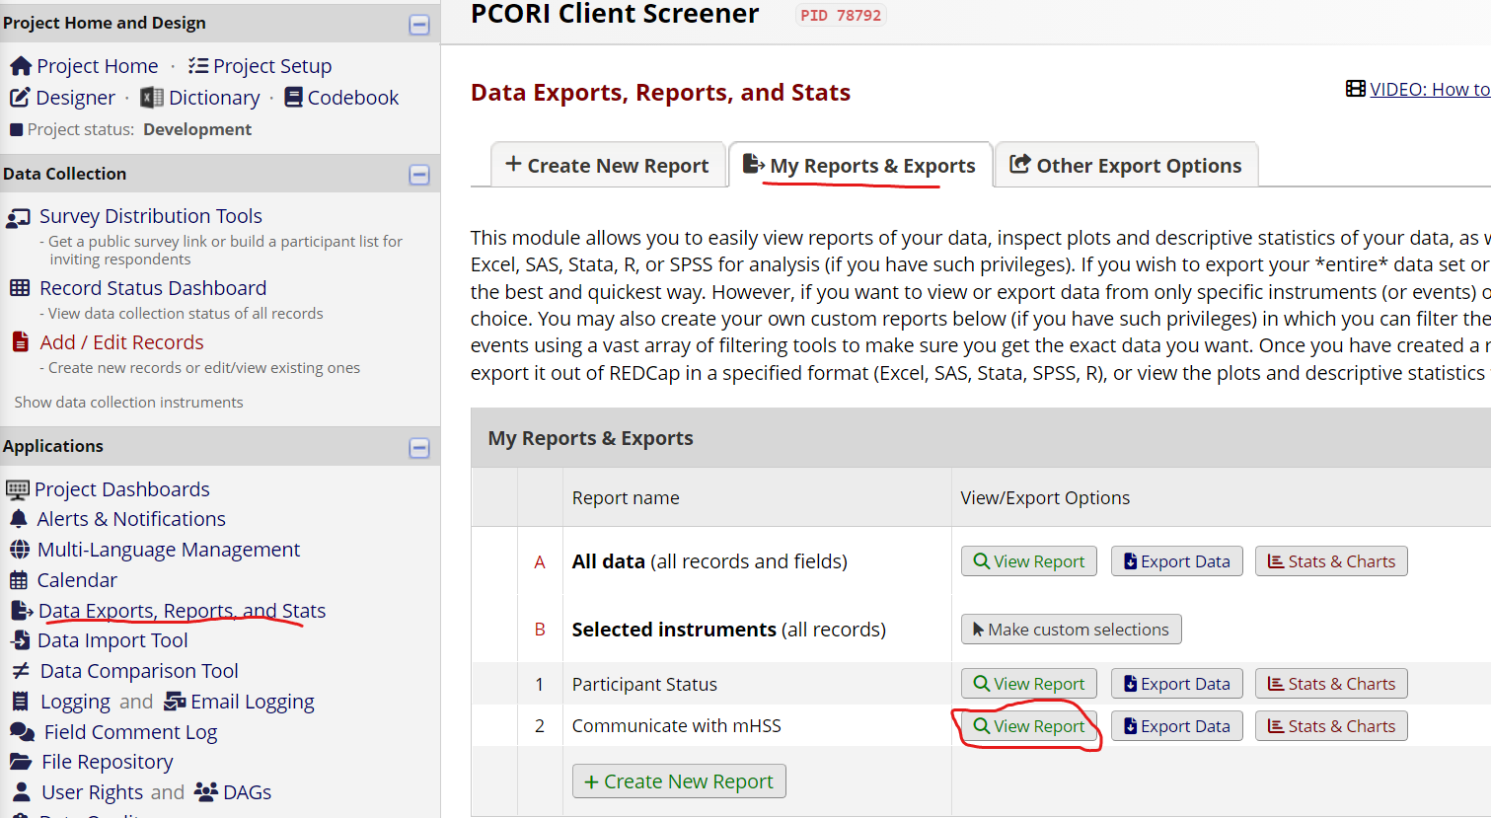
- Check if the last column, ‘FOCUS credentials shared with mHSS?’ is blank for that Client ID. This means that you need to let the mHSS know that the participant is ready for FOCUS installation.
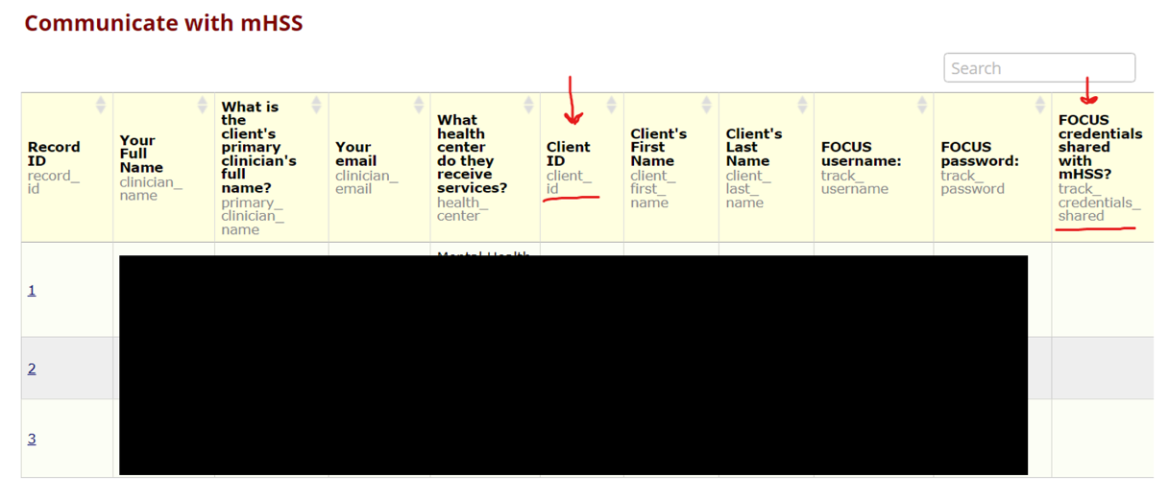
- Share the client’s name, FOCUS username, and password with their mHSS.
- Once you have done this, open the Record Status Dashboard for the same project on a new tab.

- Go to the tracker form for that participant (you can check their Record ID in the previous report).
- Say ‘Yes’ to FOCUS credentials shared with mHSS.
- Select ‘Complete’ from the drop-down and then ‘Save & Exit Form’.
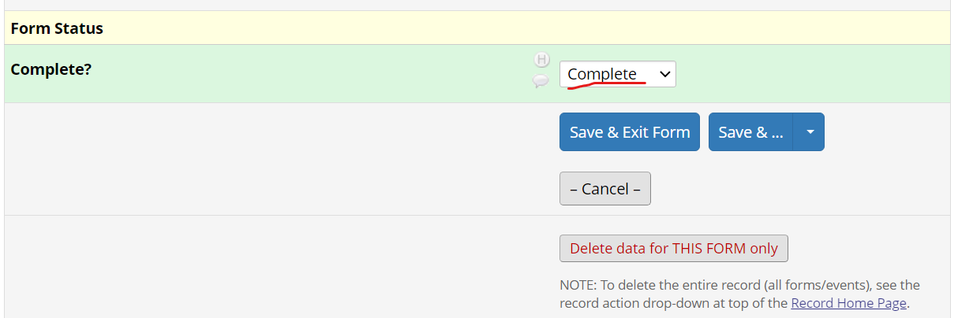
- The Record Status Dashboard will now have a green circle for that participant’s Tracker Form.
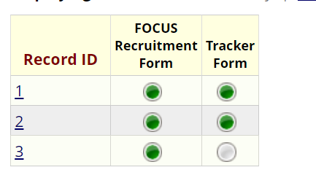
- Go to the next step, REDCap: Client 3M Setup.

Re-baseline
This step is only required if the mHSS reaches out to you about a participant that needs to be re-baselined. This can happen if the mHSS hasn’t been able to communicate with the participant after baseline and hasn’t started the intervention/installed FOCUS.
One month grace period before having to re-baseline or re-3M
- Click on Data Exports, Reports, and Stats in the ‘Client Screener’ REDCap and click on ‘View Report’ for the ‘Communicate with mHSS’ report.

- Find the Client ID of the participant who’s name was provided by the mHSS.
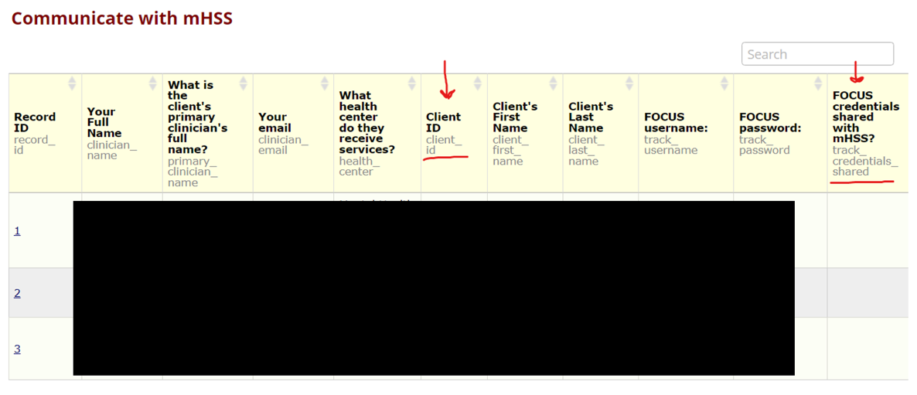
- Go to the Client Assessments REDCap and click on ‘Data Exports, Reports, and Stats’ on the left.

- Select ‘View Report’ for 3M Setup and Scheduling’.

- Click on the Record ID of the Client ID that you retreived from the Screener.

- This will open the record home page for that particular record.
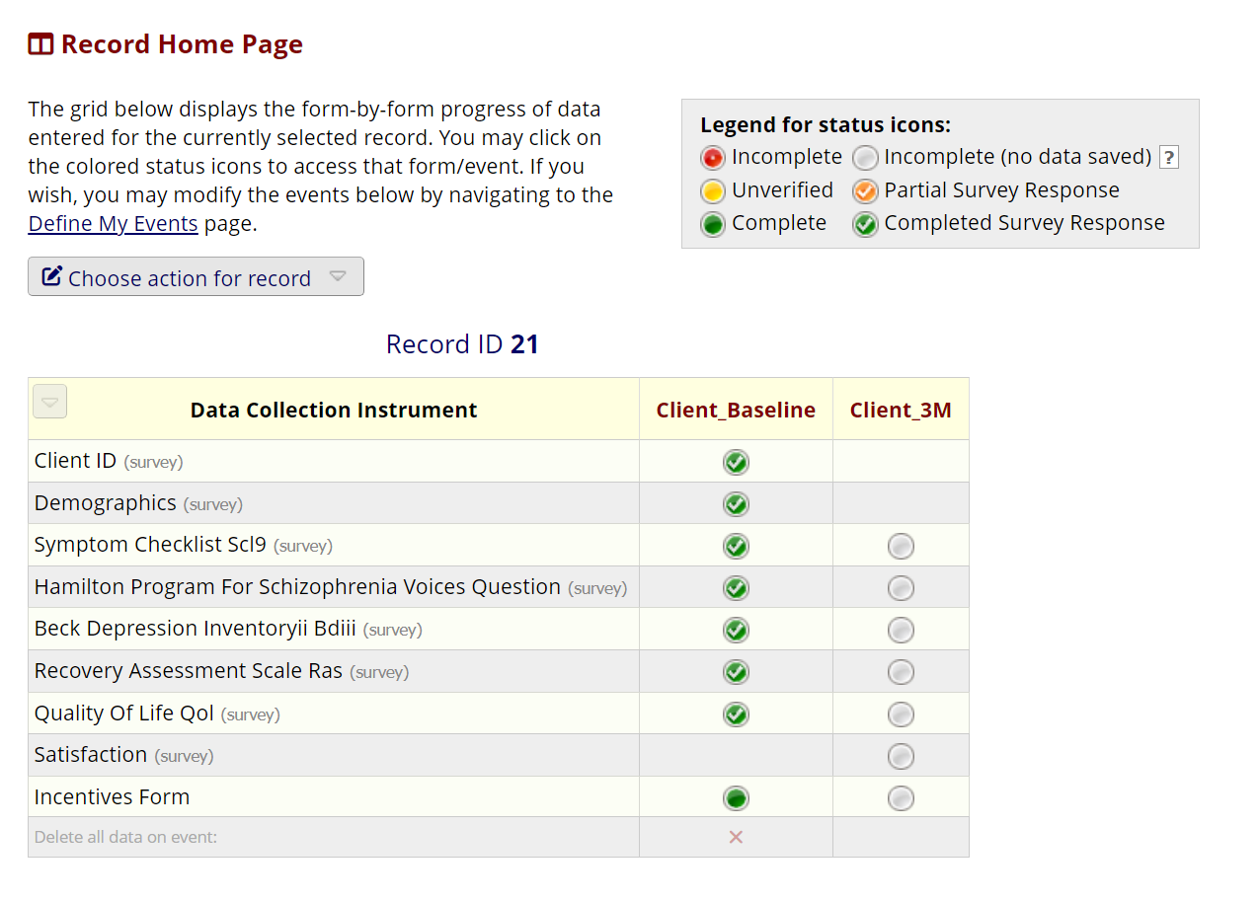
- Click on ‘Choose action for record’ and select ‘Delete record’.
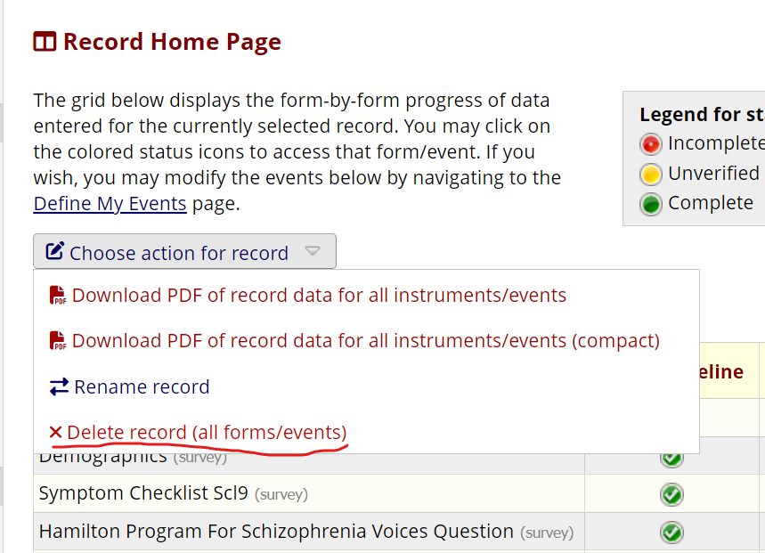
- Now redo the REDCap: Client Baseline step as if the participant is new.
- Once the participant has completed all surveys, complete the Participant Incentive step but do not send the gift card if you’ve already done this for the initial baseline.
You do NOT need to do the Setting up FOCUS Accounts: Participants step.
- Tell the mHSS that the participant is ready for FOCUS installation.

FOCUS Installation
This is information on how to install FOCUS on Android and iOS. mHSS are already trained in this, but you can provide them with this information in case they need some assistance.
For Android -
- Participants are given a link to the unlisted page on the Play Store.
- They install the app directly from there.
- Alternatively, they can sideload APK from website.
For iOS -
- Participants install TestFlight on their phone.
- They are given a URL that opens the FOCUS app on TestFlight.
- They need to click on the app on TestFlight and enable ‘Automatic Updates’ under ‘App Information’
- They can then install FOCUS directly from TestFlight.

REDCap: Client 3M Setup
- When the mHSS shares the name of a participant who installed FOCUS, open the ‘Communicate with mHSS’ report in the Client Screener project.
- Check the Client ID for that participant.
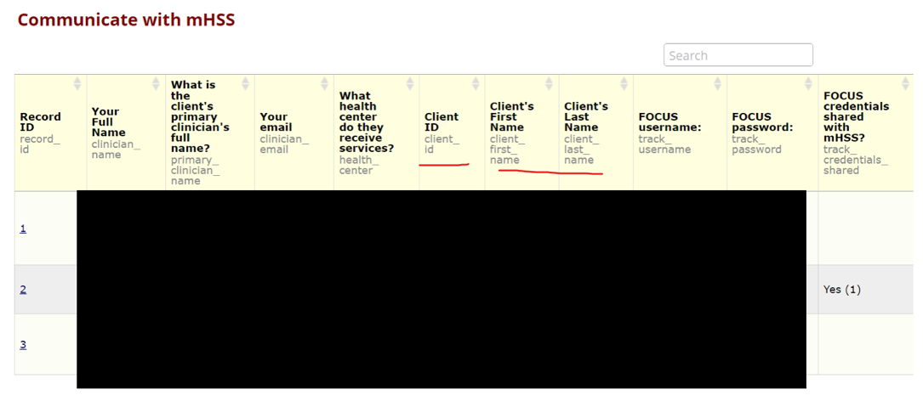
- Open the Client Assessments REDCap on another tab and click on ‘Data Exports, Reports and Stats’ in the Client Assessments REDCap.
- Click on ‘View Report’ next to the 3M Setup and Scheduling report.
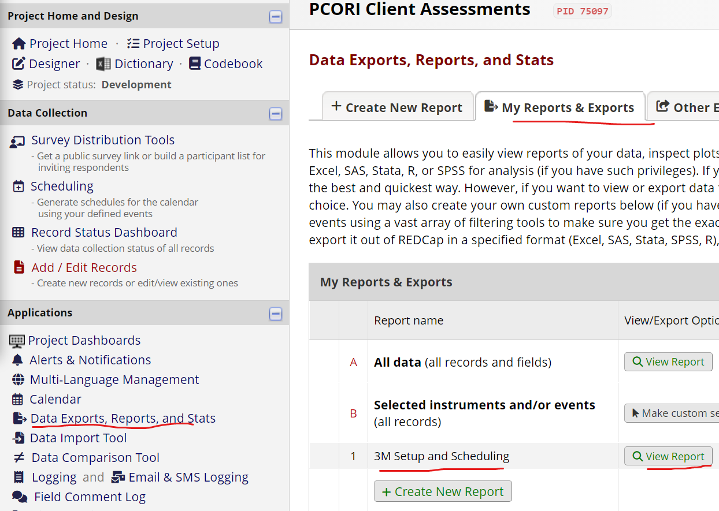
- Confirm that a participant has completed all surveys by checking the last column.

- Click on the record ID linked to the Client ID who has installed FOCUS.
- This will open the Record Home Page for that particular record. Click on the Incentives Form for that record.

- Put in the date that the client installed FOCUS in ‘Treatment Start Date’. This is IMPORTANT because the 3M surveys are automatically sent 90 days from this date.
- Now open Scheduling in Client Assessments on a new tab.
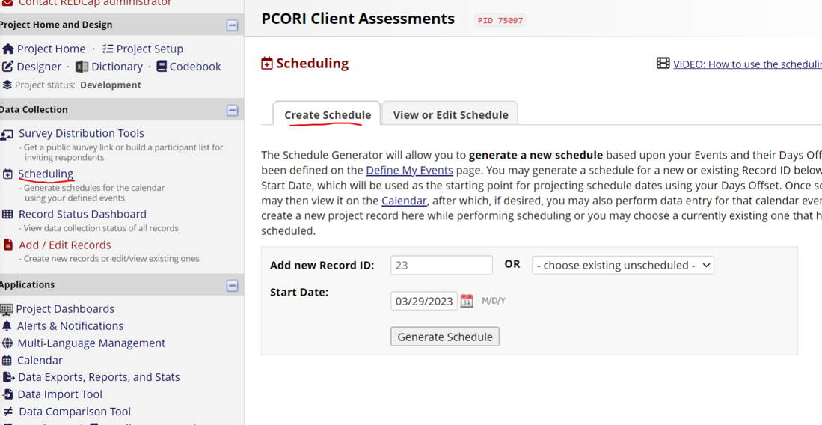
- Select the Record ID in the drop-down list on the right (you can find the ID on the previous Record Home Page tab). Make sure the ‘Start Date’ is the day they installed FOCUS and then click on Generate Schedule.
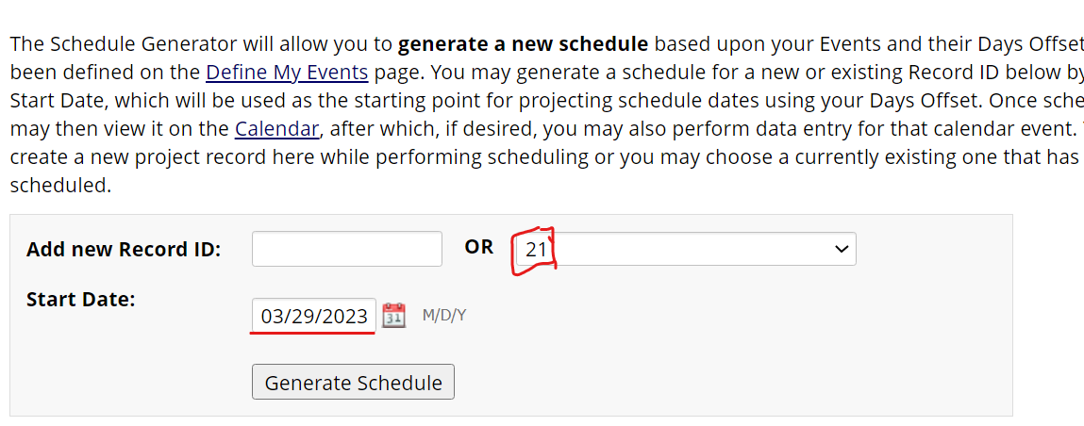
- Choose the second date to be 3 months from the date the participant installs FOCUS. Click create.
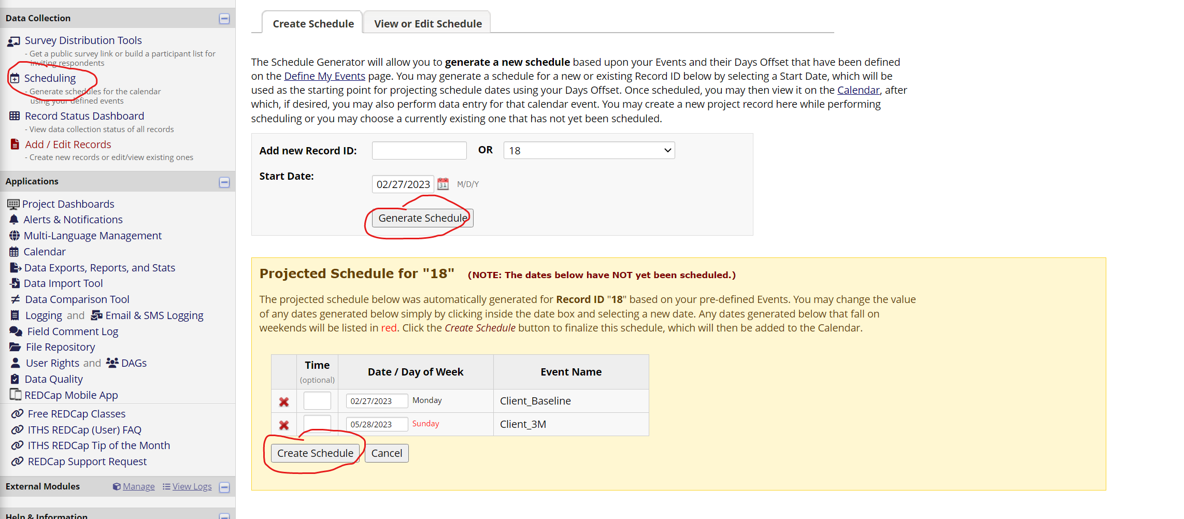
Now, the 'Project Home’ page calendar will show when there are upcoming assessments. This is useful when you need to inform the mHSS that a 3M assessment is coming up for a participant.
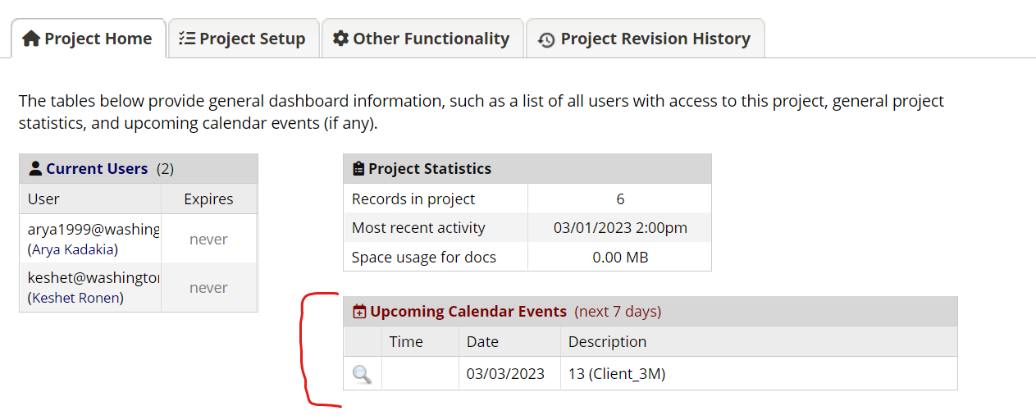
- Go back to the Record Home Page on the previous tab. Click on Incentives Form.

- Select ‘Yes’ to ‘Follow-up schedule created?’.
- Change the Form Status to ‘Complete’ and then press ‘Save & Exit Form’.
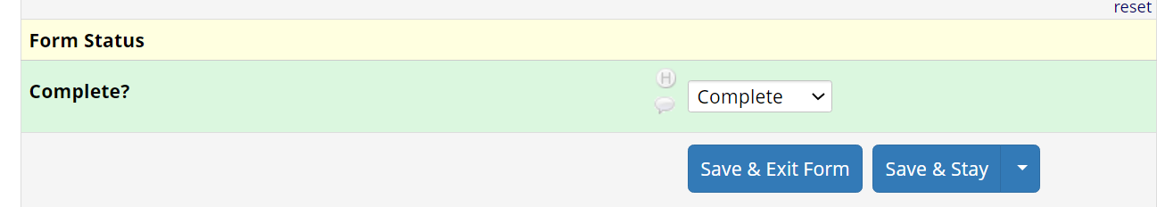
- The Incentive Form will now have a green circle next to it.
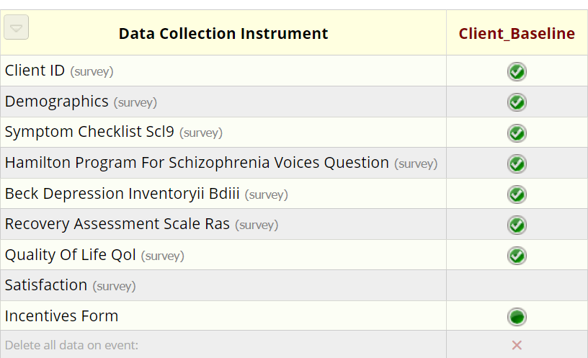
- Go to next step, REDCap: Client 3M

Alerts and Notifications
You only need to perform this step one time to ensure that you receive relevant alerts.
- Go to ‘Alerts and Notifications’ in the ‘Client Assessments’ project.
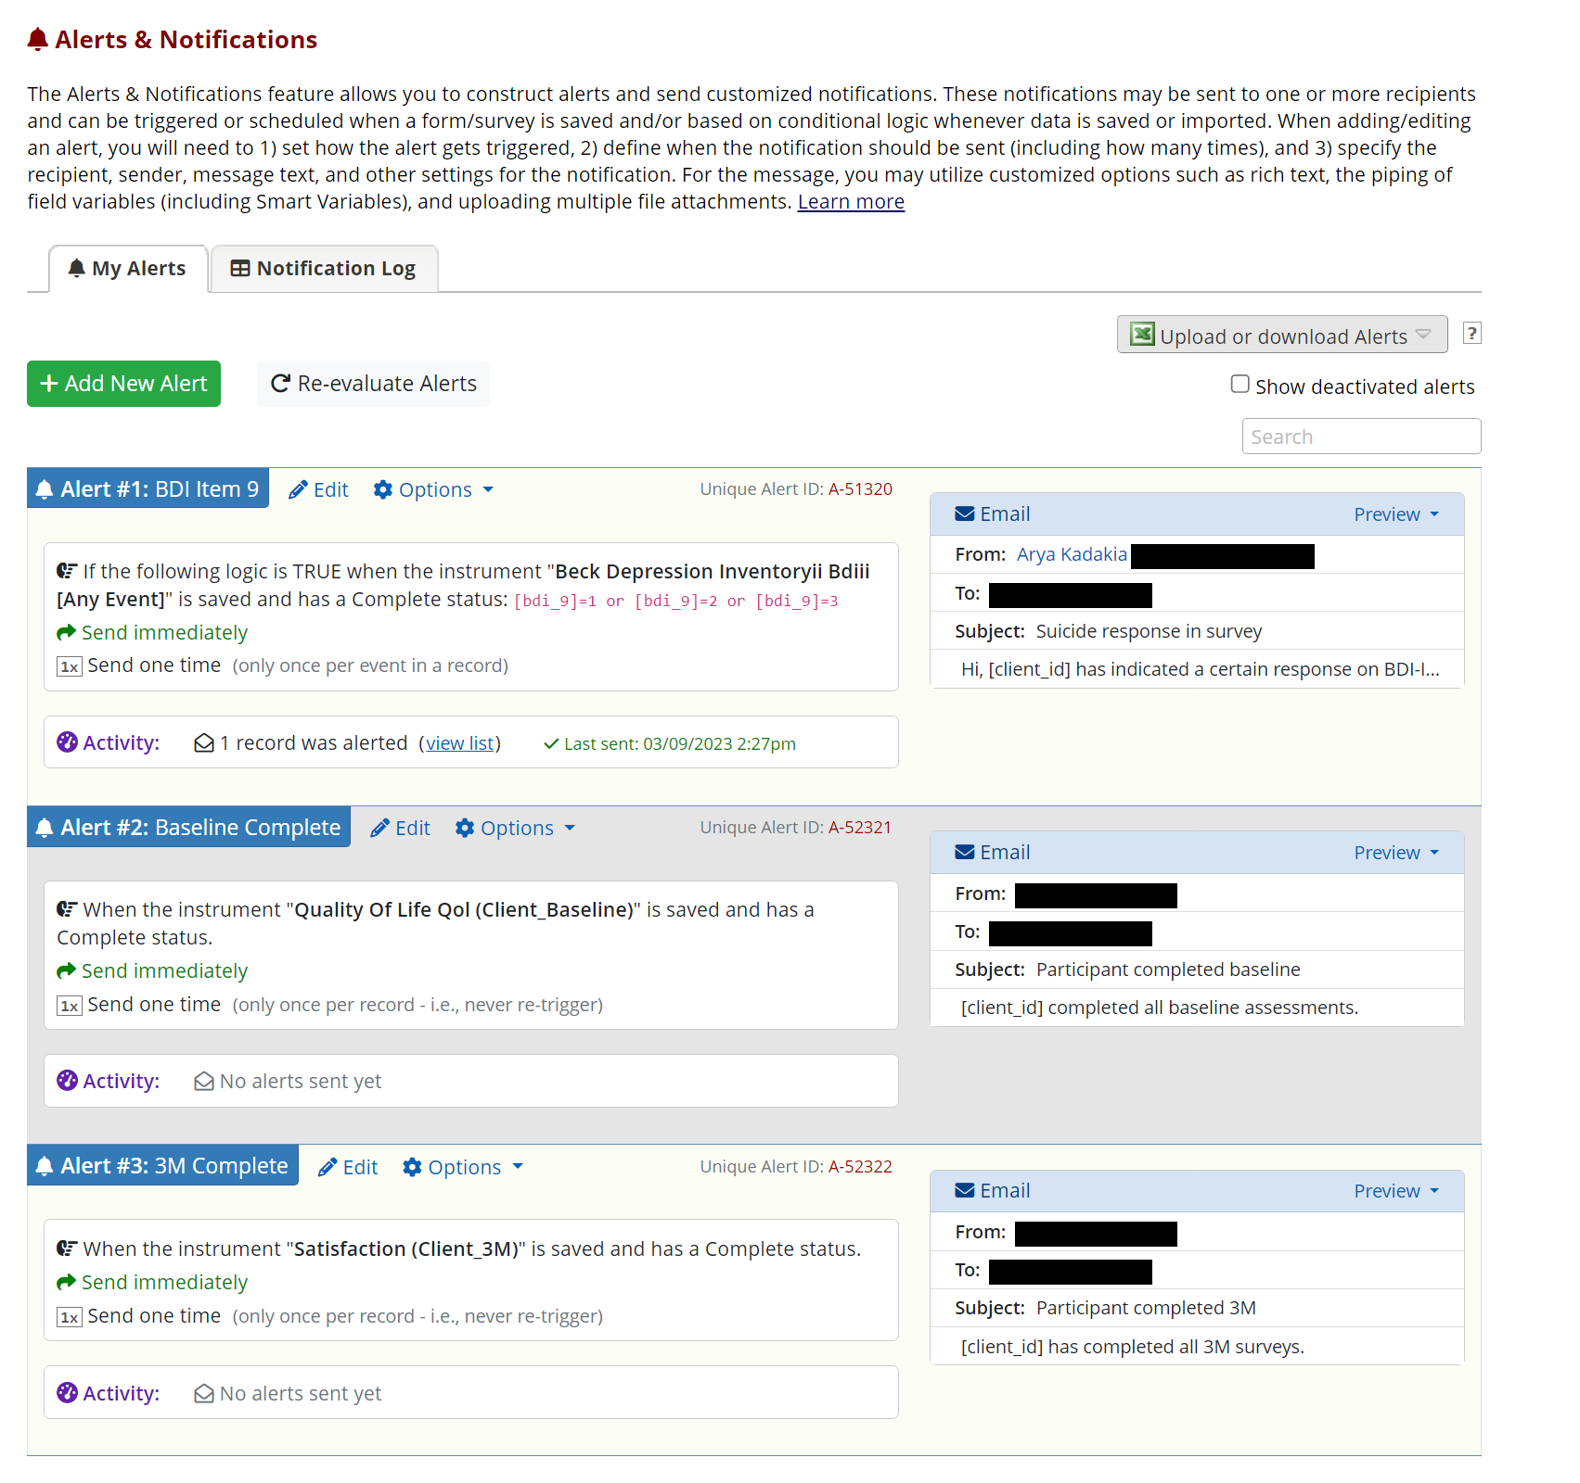
- Click ‘Edit’ for EACH of the 3 alerts (BDI Item 9, Baseline Complete, and 3M Complete) and add your email as a recipient (if this is your first time)

You will be notified via email when a participant has -
  - Entered a suicidal response on the BDI’s Item 9 that warrants a response.
  - Completed all baseline assessments
  - Completed all 3M assessments
You will get their Client ID and Record ID as well.
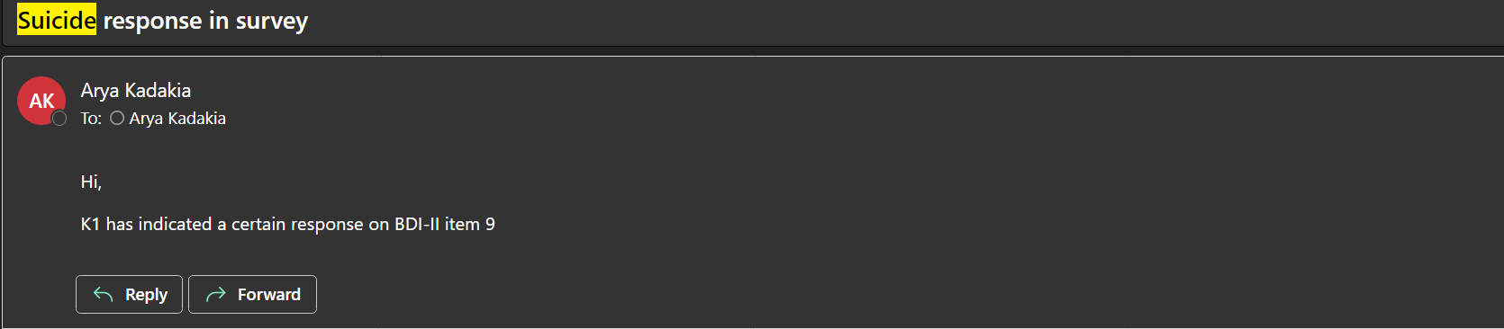
The following steps are only needed when you receive an email saying that a participant has indicated suicidality in the BDI-II and to know what to do in that case. You DO NOT need to do this every time you recruit a participant.
- Once you get this email go to the ‘Client Screener’ REDCap.
- Go to the Participant Status report in Data Exports, Reports, and Stats.
- Identify the Client ID’s name and email.
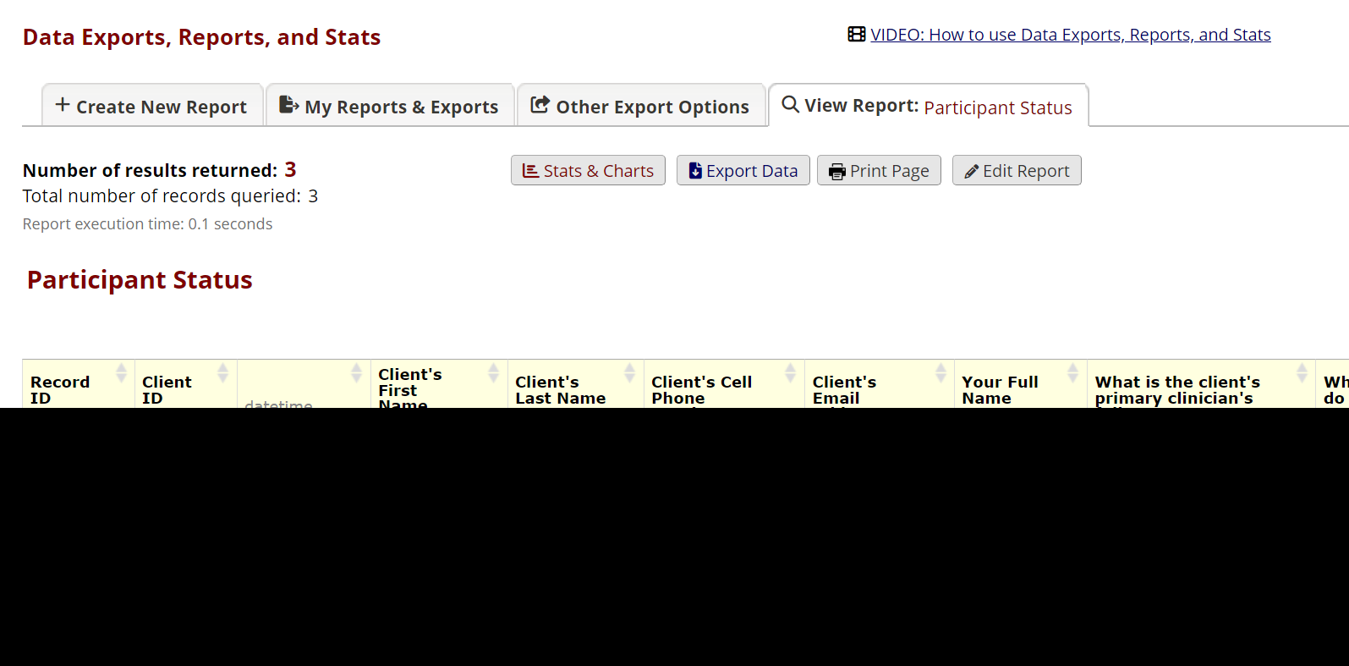
- Send them the following email. If no email is listed, mail a letter to their home address:
Hello,
We are reaching out to you from the FOCUS team.
You completed an online questionnaire and, on the question, 9. Suicidal Thoughts or Wishes you indicated a score of 1 or higher. We are sorry to hear you feel this way.
First, if you have a primary care, mental health provider or other clinical provider, we recommend that you consider reaching out to them to let them know you feel this way.

Second, please consider using the following resource:
Suicide Prevention Lifeline
The National Suicide Prevention Lifeline connects you with a crisis center in the Lifeline network closest to your location. Your call will be answered by a trained crisis worker who will listen empathetically and without judgment. The crisis worker will work to ensure that you feel safe and help identify options and information about mental health services in your area. Your call is confidential and free.
1-800-273-8255
https://suicidepreventionlifeline.org/

Finally, if you feel you are unable to remain safe from harm, and require emergency support, please dial 988.

Remember, you are not alone. Resources exist to provide you support.

Thank you for participating in the study.

The FOCUS Team
REDCap: Client 3M
- Go to the Project Home of the ‘Client Assessments’ REDCap.
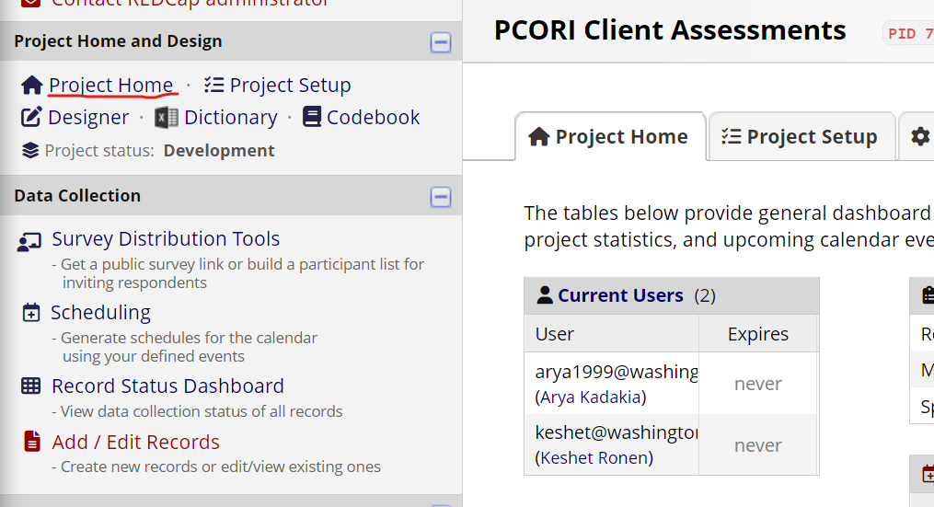
- Check the calendar on the right to see if there is an upcoming 3M in the next 7 days. Identify the Record ID (for instance, 13).
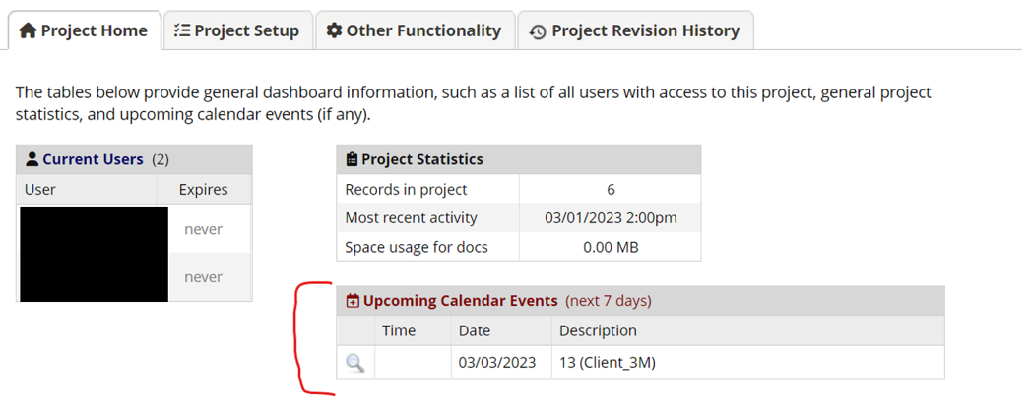
- Go to the ‘3M Setup and Scheduling’ report in ‘Data Exports, Reports and Stats’.

- Check the client ID of the particular record ID.
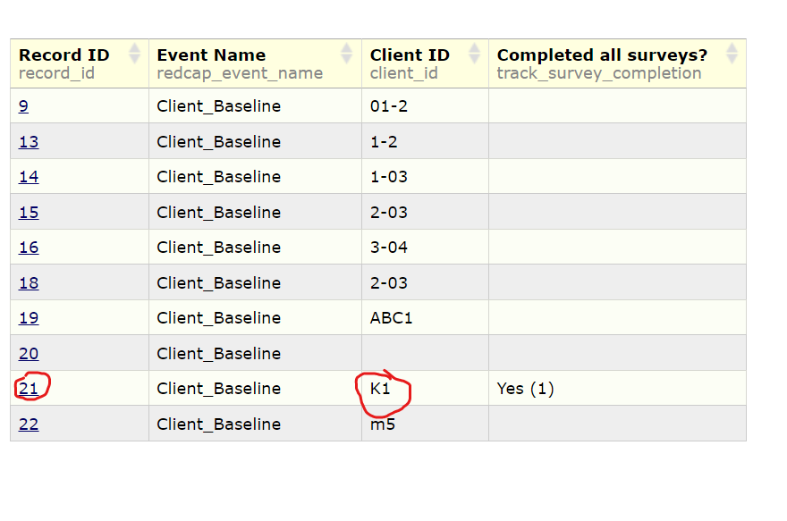
- Open the Client Screener project on another tab.
- Go to ‘Data Exports, Reports, and Stats’ and click on ‘View Report’ for ‘Communicate with mHSS.
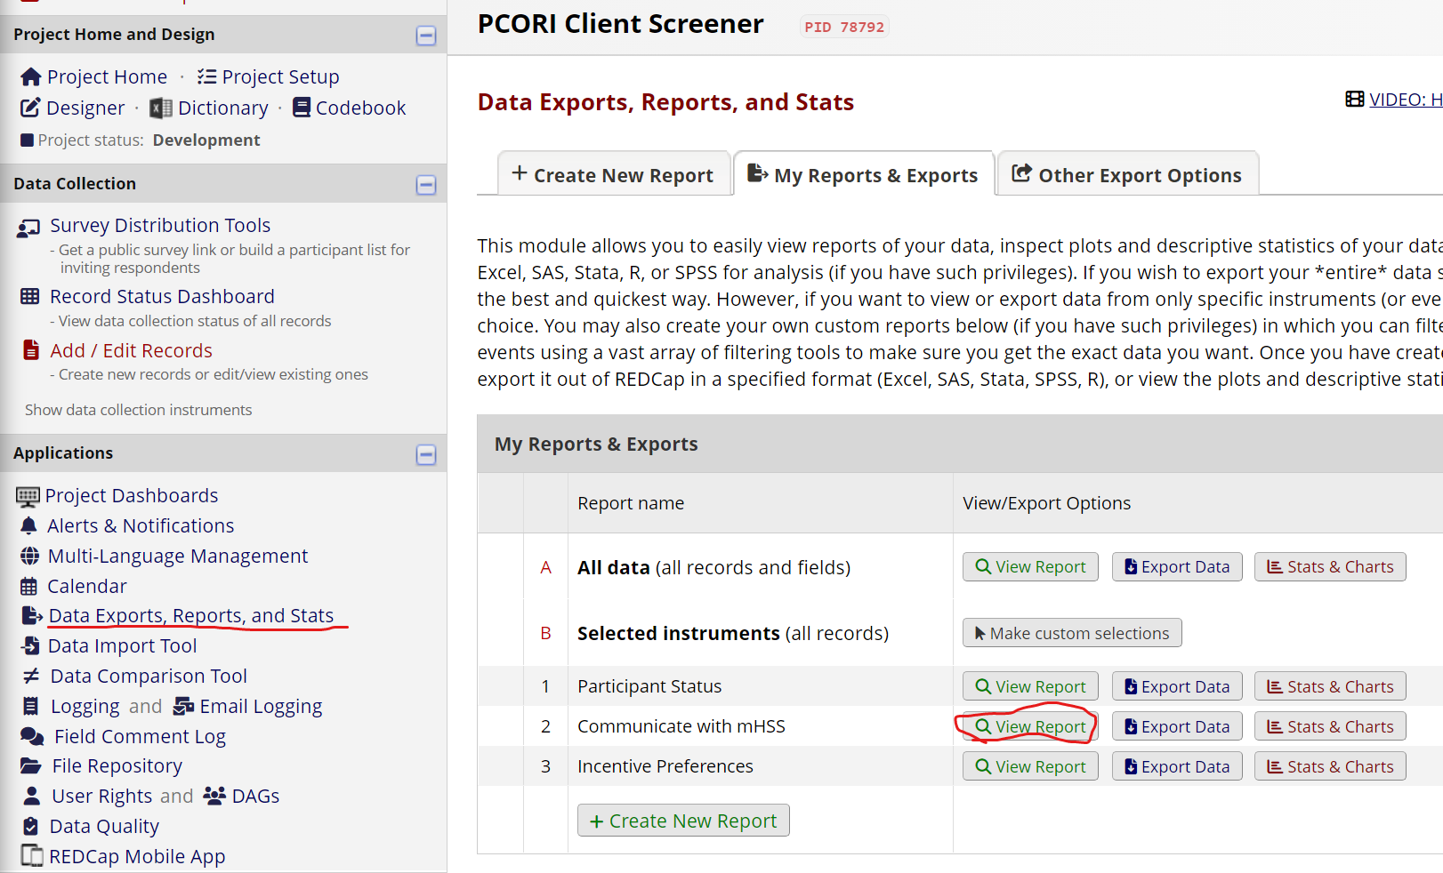
- Identify the participant’s name and FOCUS ID based on their Client ID.
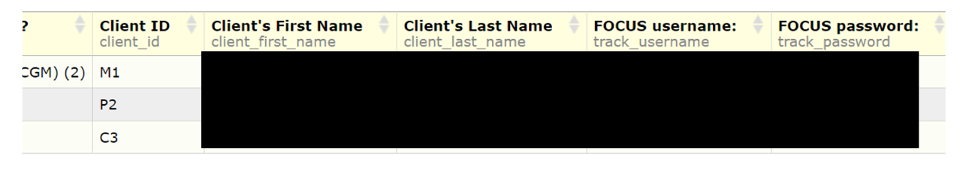
- Share these details with the mHSS and let them know to inform the participant about their upcoming assessment.
The link to the 3M should be sent automatically to the participant 90 days from when their treatment started. They will get sent the following text along with a link to their first 3M assessment -
Hi there! Thank you for completing the intervention part of the study. Below is a link to your next questionnaire.

Please make sure to have a good WiFi or data connection and be in a quiet place without distractions.

The questionnaire should take between 30-60 minutes.

If you have questions, you can text us on XXX-XXX-XXXX.

Thank you!
[survey-url]

The intervention period is a consistent 12-weeks from the installation date. If a coaching call is missed or skipped for a given week, this does not extend the intervention period.
- Once participant has completed their 3M assessments, you will receive an email with their Client ID and Record ID.
- Follow steps in REDCap: Client Baseline starting from step 21.
- Follow the Participant Incentive steps to send out gift cards.

